**Check Lifecycle.pdf**

**Lifecycle hooks of Component**

Whenever a new component is created angular and the selector is binded angular will instantiate a new version of this component and add it to the DOM ,

Once the new Component is instantiated Angular goes for a couple of different phases in this creation process and gives us a chance to hook into these phases and execute code by implementing some lifecycle methods

**1) ngOnInit**

This is called once the component is initialized in the DOM , ngOnInit will run after the constructor

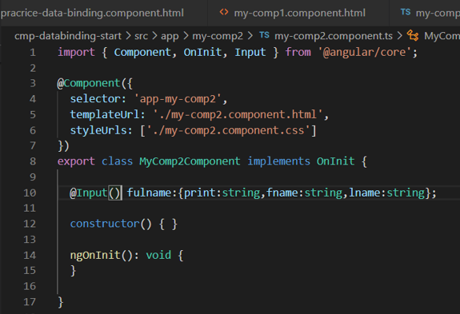

**2)ngOnChanges**

This can be executed multiple times first at the start when a new component is created there after it is always called after a bound input property changes ie: property decorated with @Input() ,so whenever these properties receive new values it is called

Eg:

  @Input() fulname:{print:string,fname:string,lname:string};

**3) ngDoCheck**

This gets executed a lot of time this runs whenever the change detector in angular runs ,change detector is that which detects the change in the templated of the component that needs to be rendered

eg: a button click or any event or any time or any observable was resolved

On all like these occasions it will check your code and ngDoCheck will be executed

**4) ngAfterContentInit**

This is called whenever the content projected via <ng-content> is initialized and projected to the view

Below is the content **between** <app-my-component2>

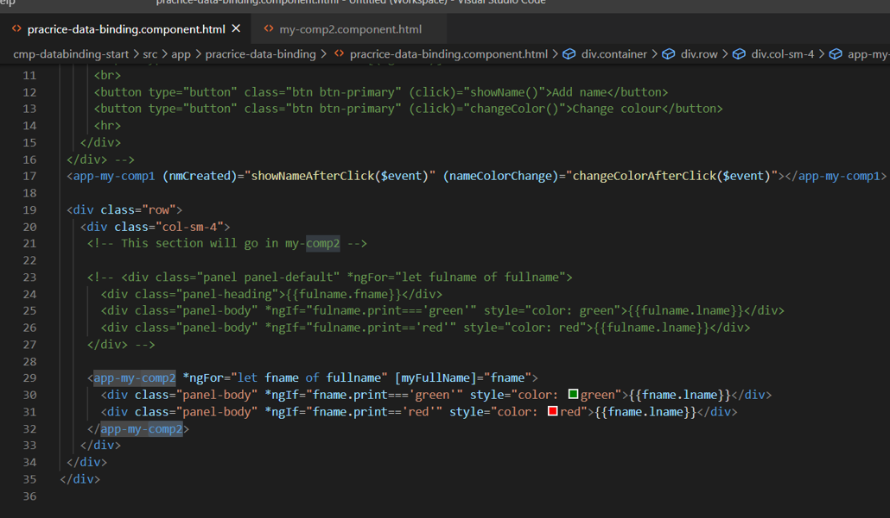

Ng-content is where the above content will be shown

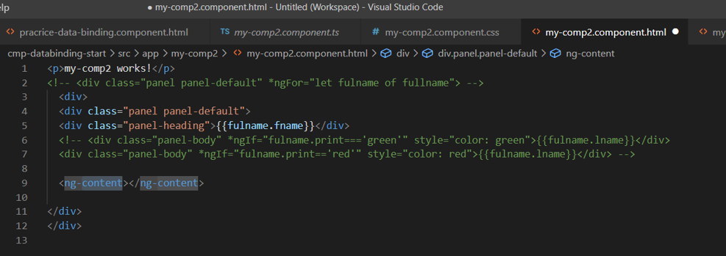

**5) ngAfterContentChecked**

This is called everytime the projected content has been checked

**6) ngAfterViewInit**

This is called after the components view (and child view ) has been initialized

7) ngAfterViewChecked

This is called everytime the view (and child views )have been checked and there are no new changed detected by angular

8) ngOnDestroy

This is called once the component is about to be destroyed (Removed from Dom ) this is great for cleanup because this is called right before the object is being destroyed

Working of lifecycle hooks

1)ngOnInit

We add console .log msg to see what gets called first

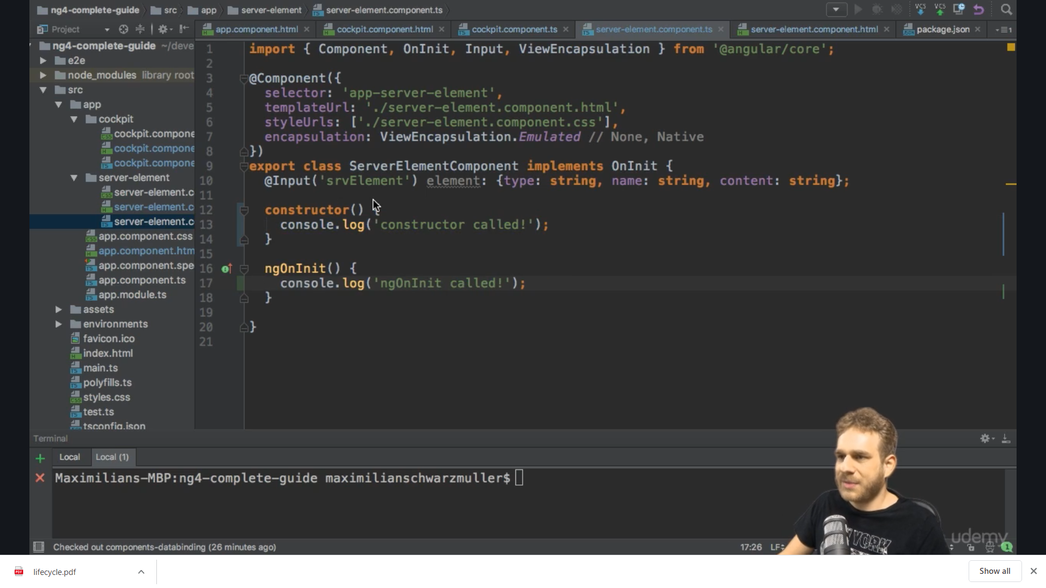

Console shows constructor called first everytime

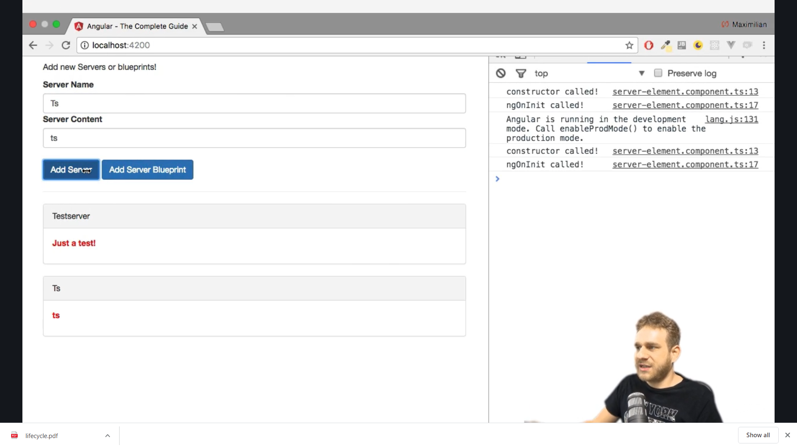

2)ngOnChanges

We implement the method ngOnChanges from OnChanges interface which our class is extending

We again

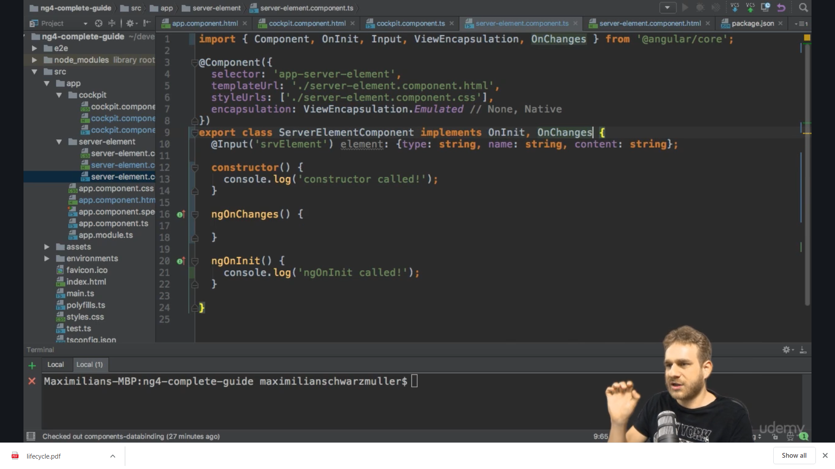

This is the only lifehook method which expects arguments ngOnChanges(**changes:SimpleChanges**) and we log changes to console

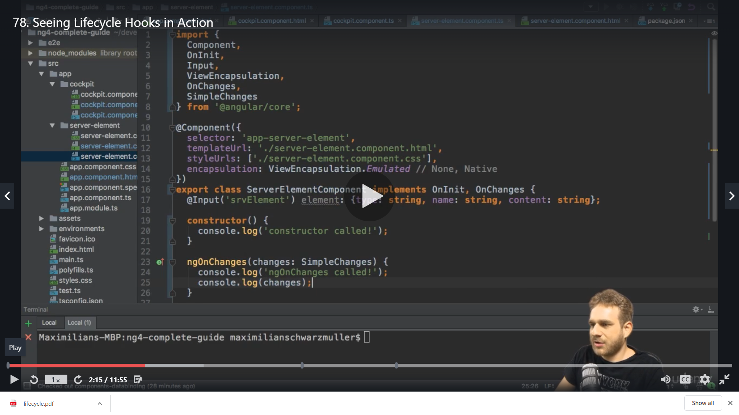

First constructor >>ngOnChanges>>onInit

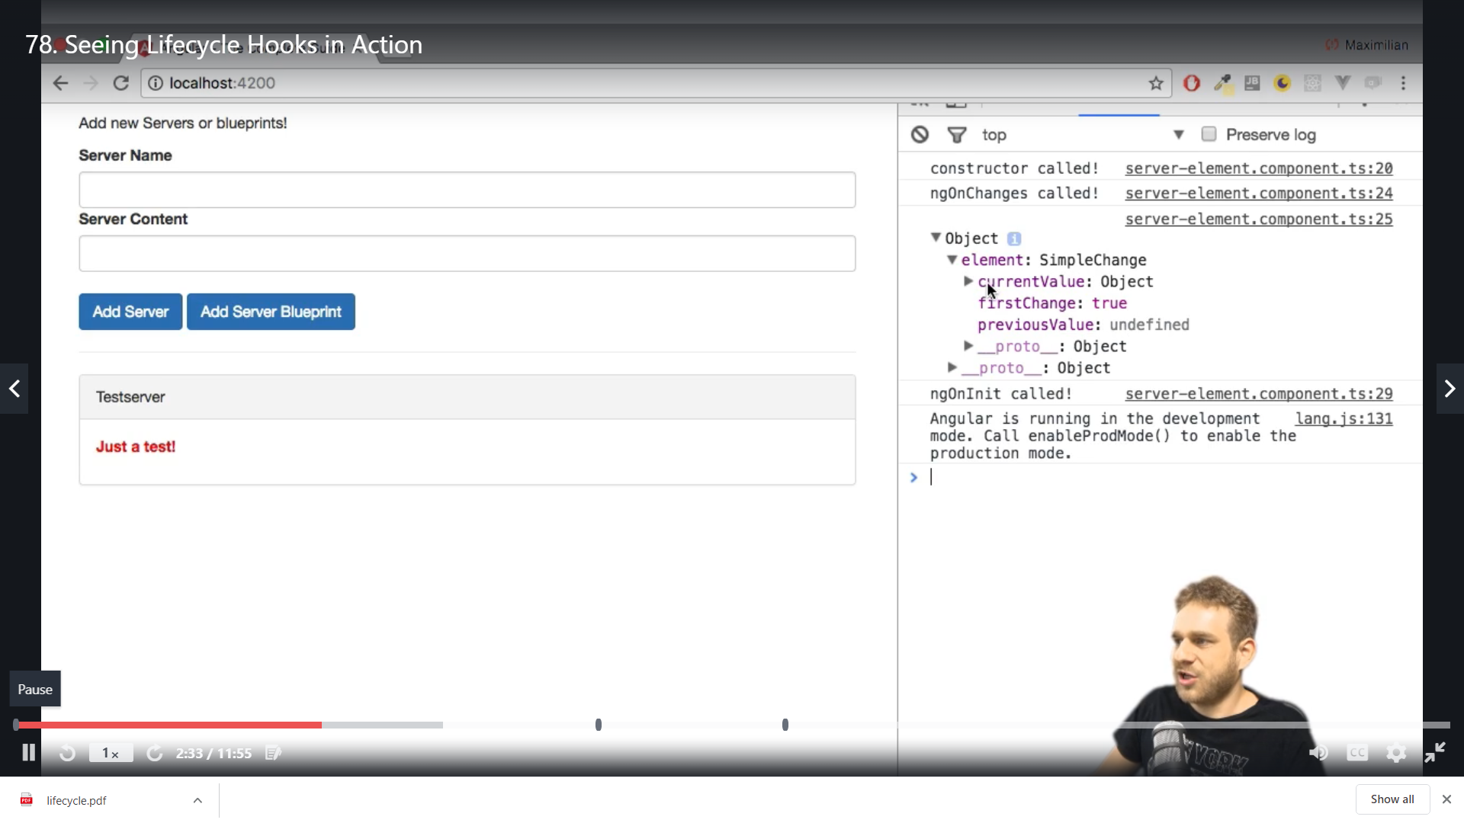

The element name is this below which is highlited

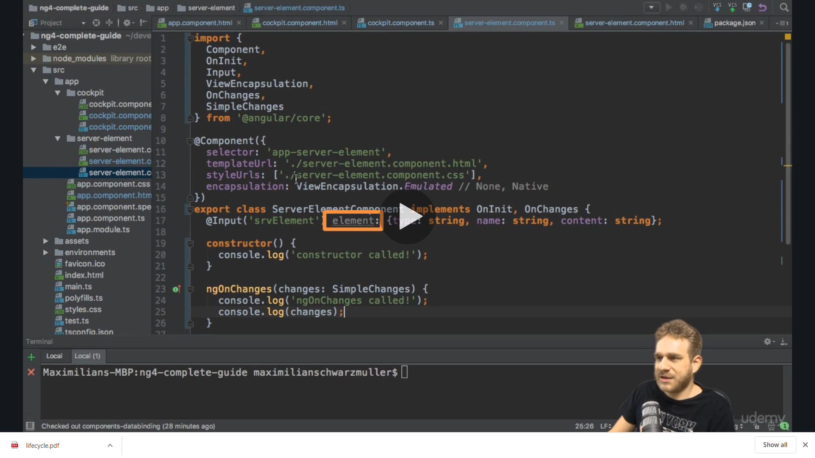

We add new buttong and on its click again ngOnchanges gets fired not the constructor and onInit

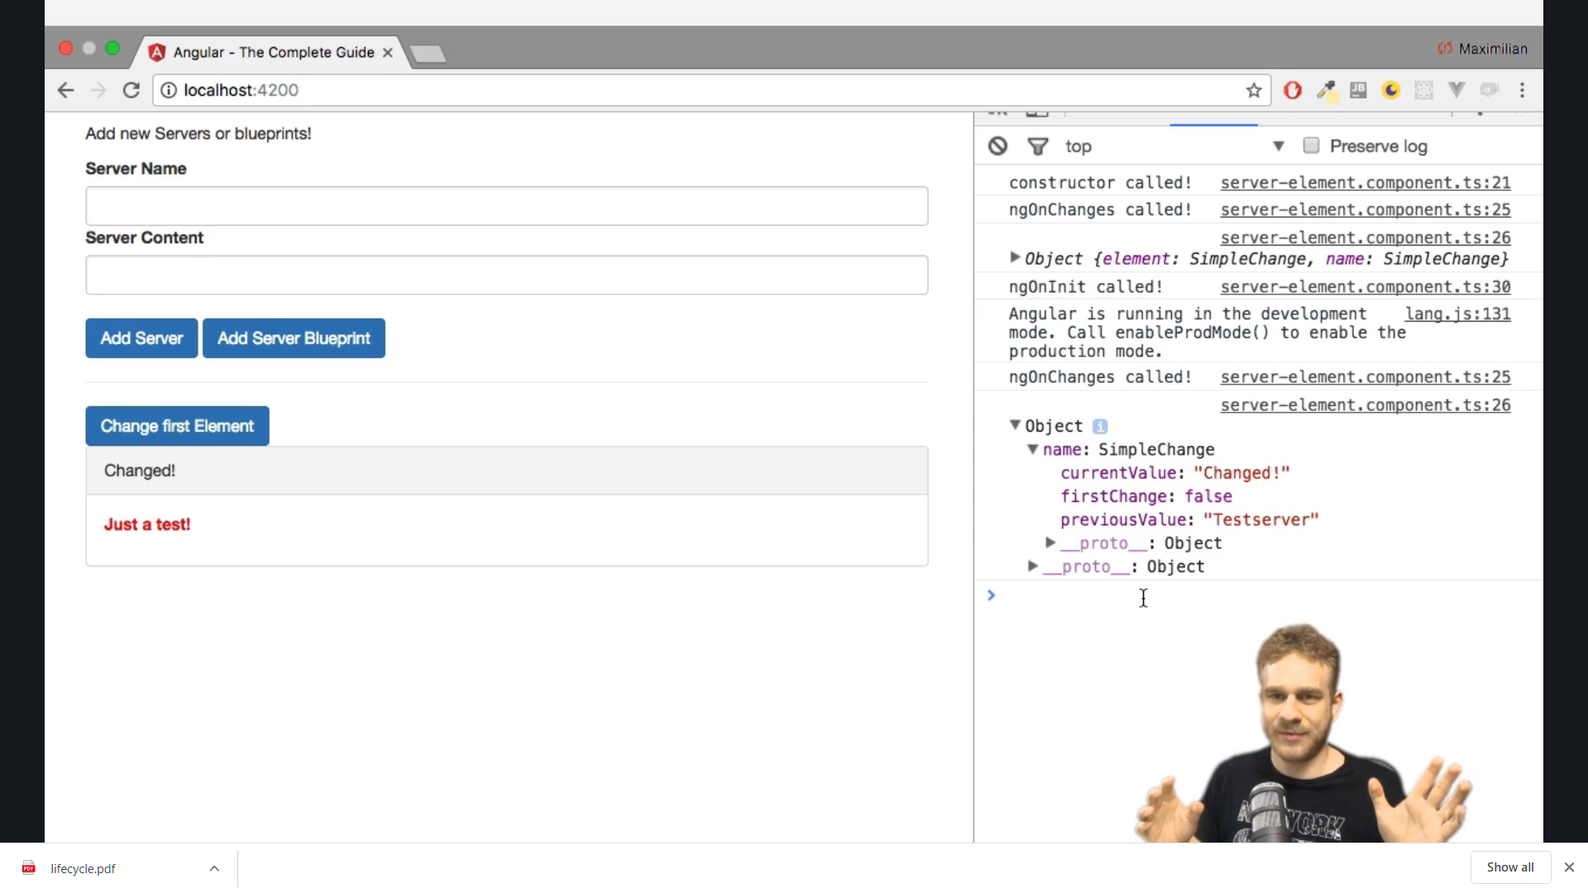

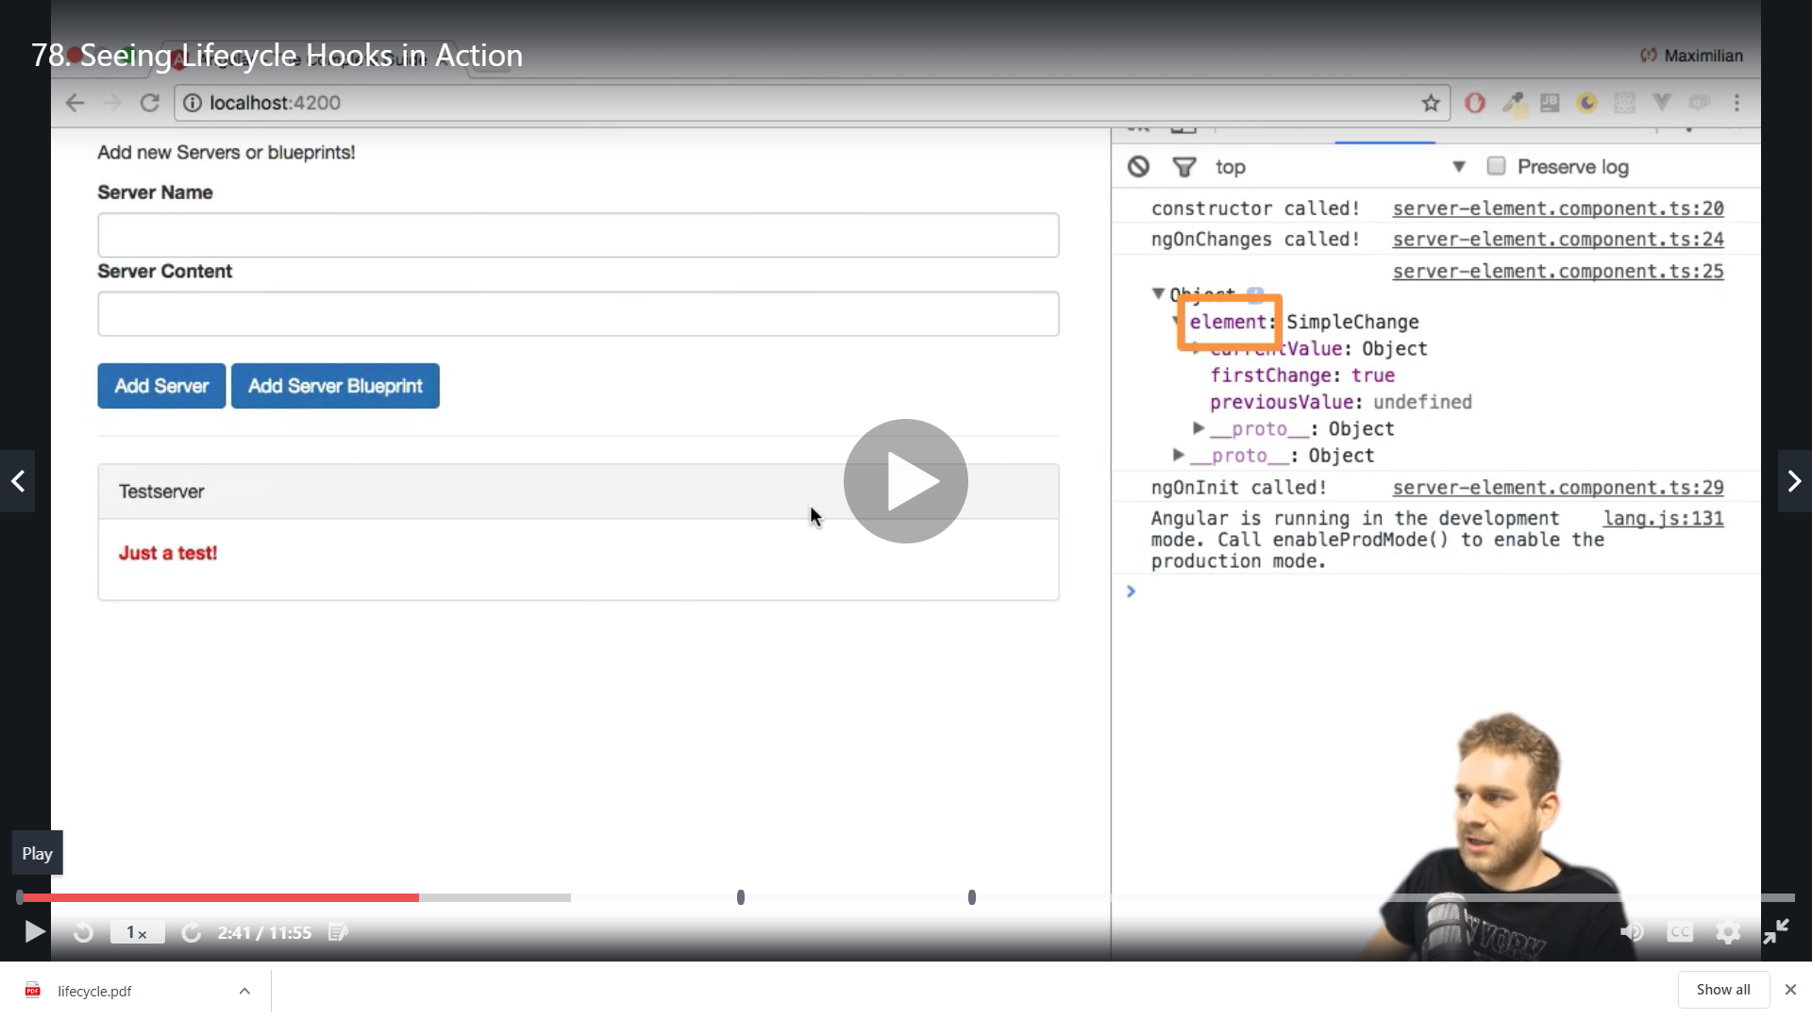

3) ngDoCheck

We log the console all these methods are from core package and our class is extending these interfaces

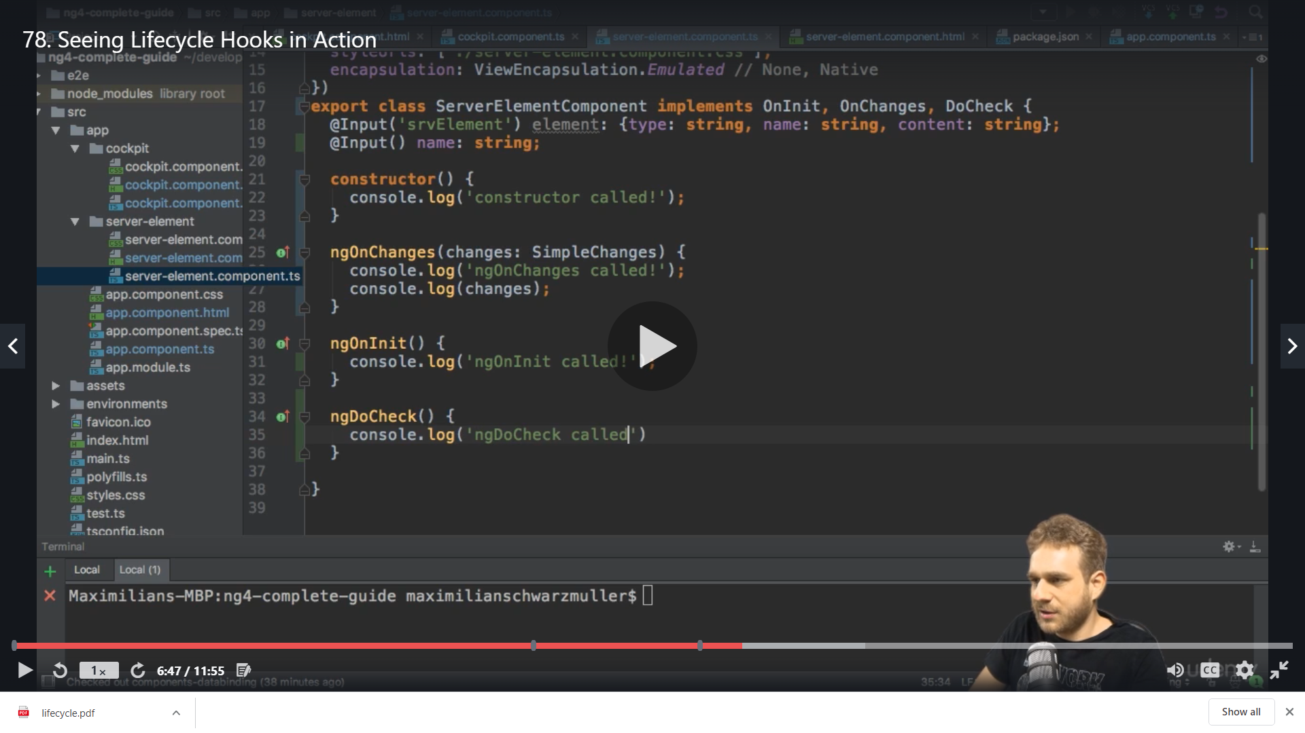

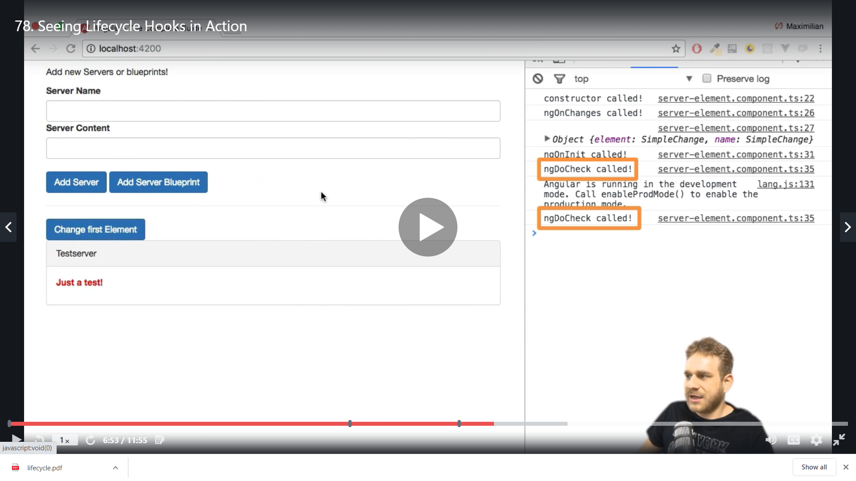

We click all buttons and it gets called everytime

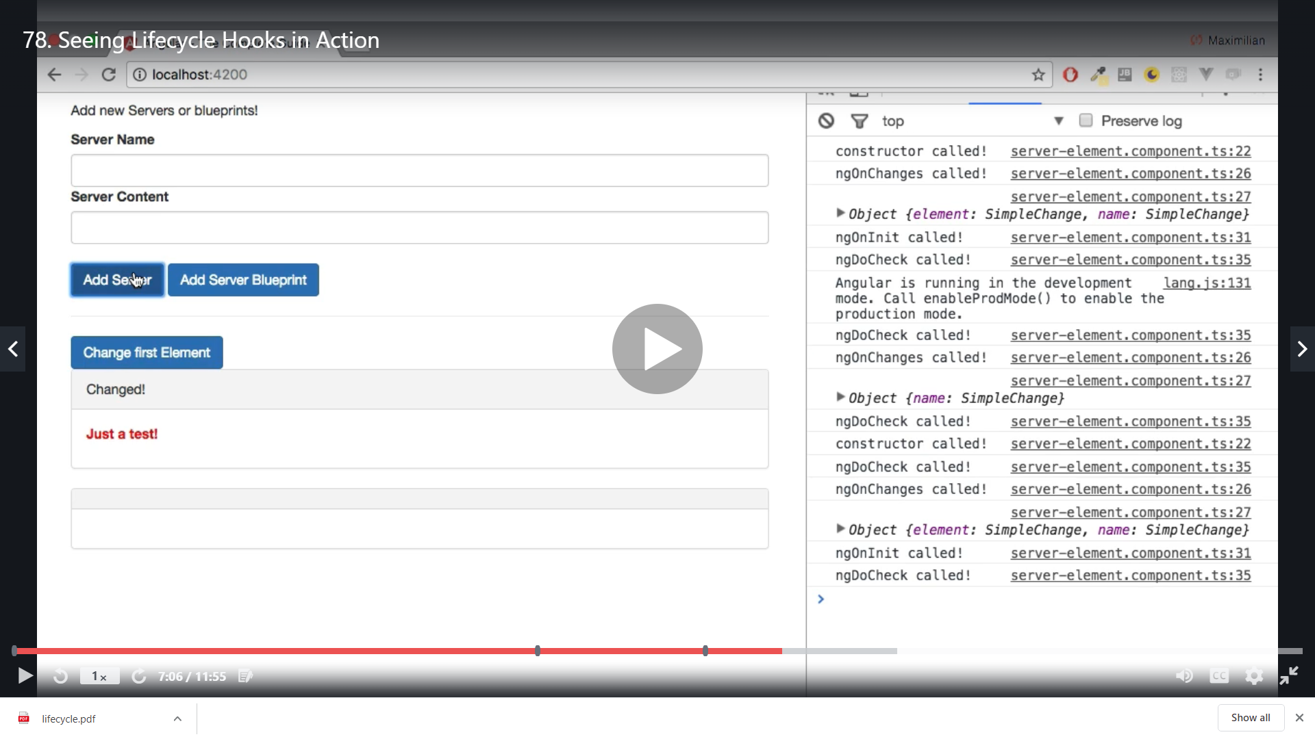

4) ngAfterContentInit

We log to console after implementing the method

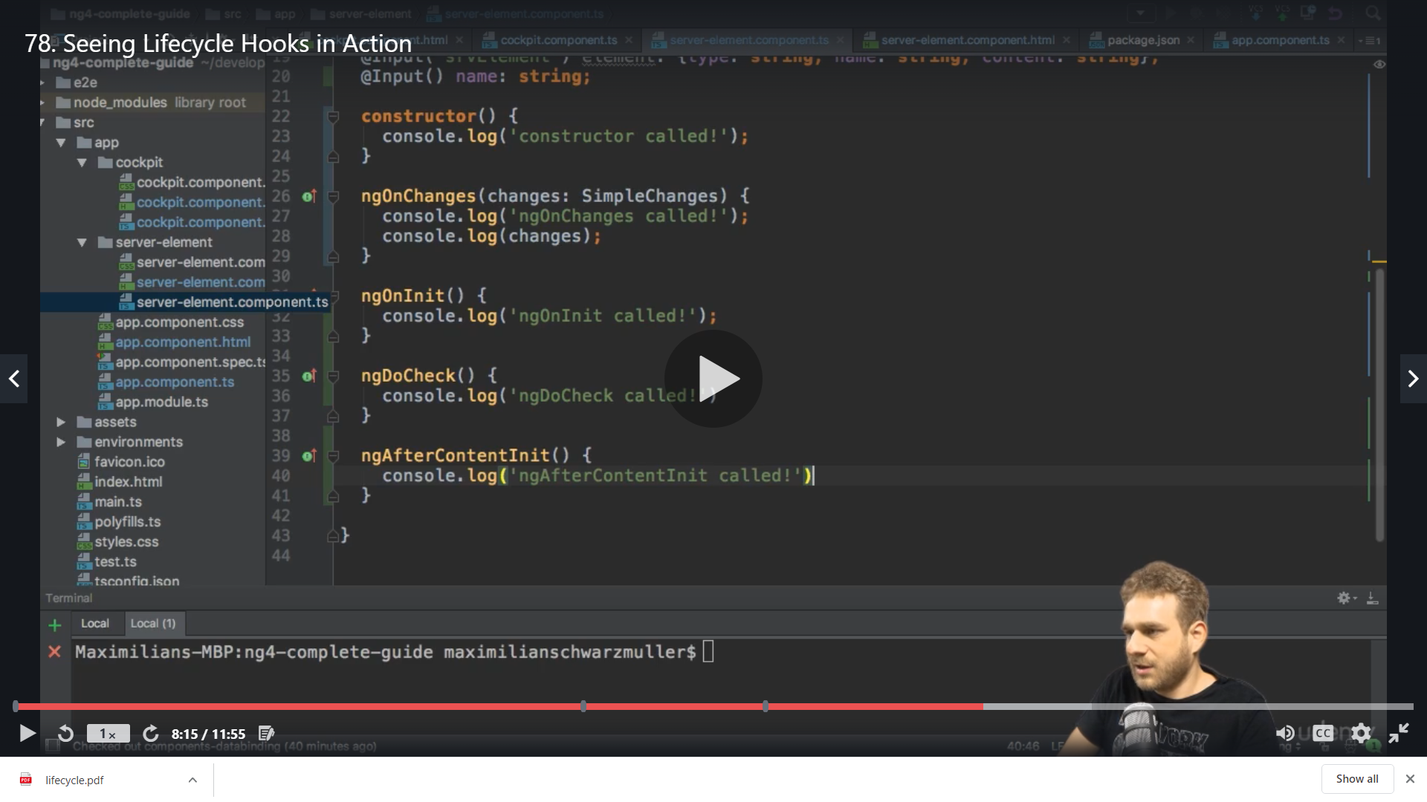

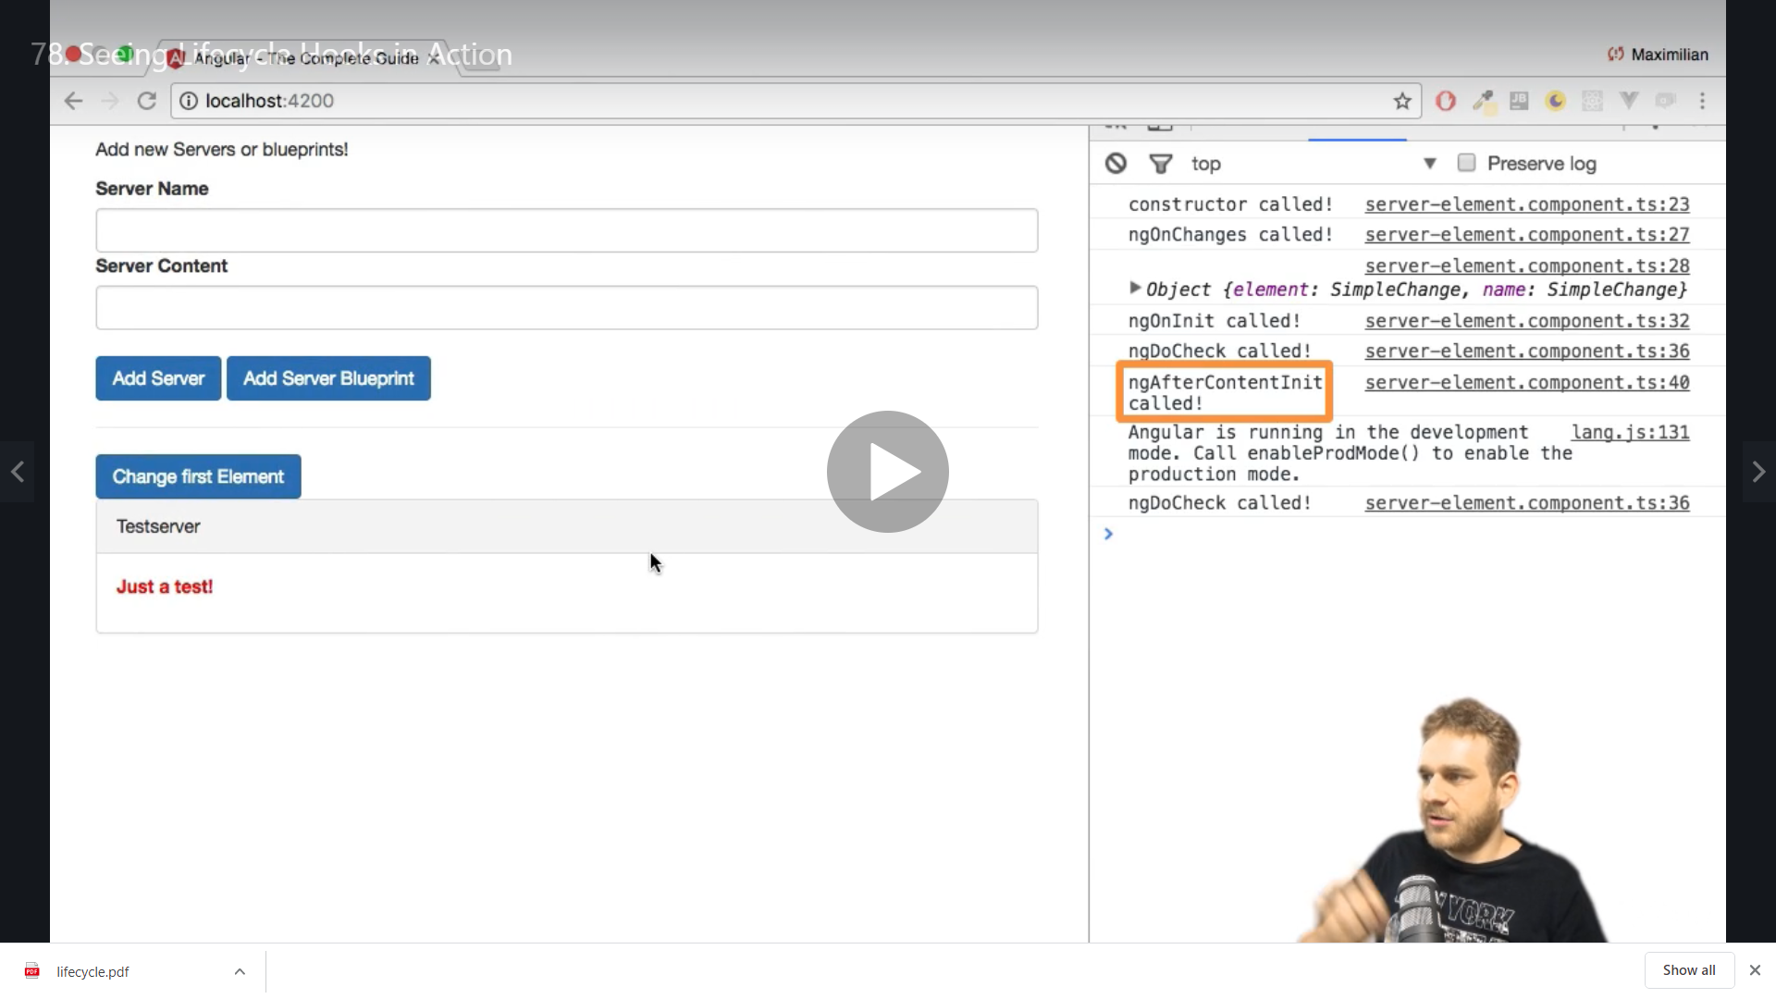

5)ngAfterContentChecked

We log console after implementing

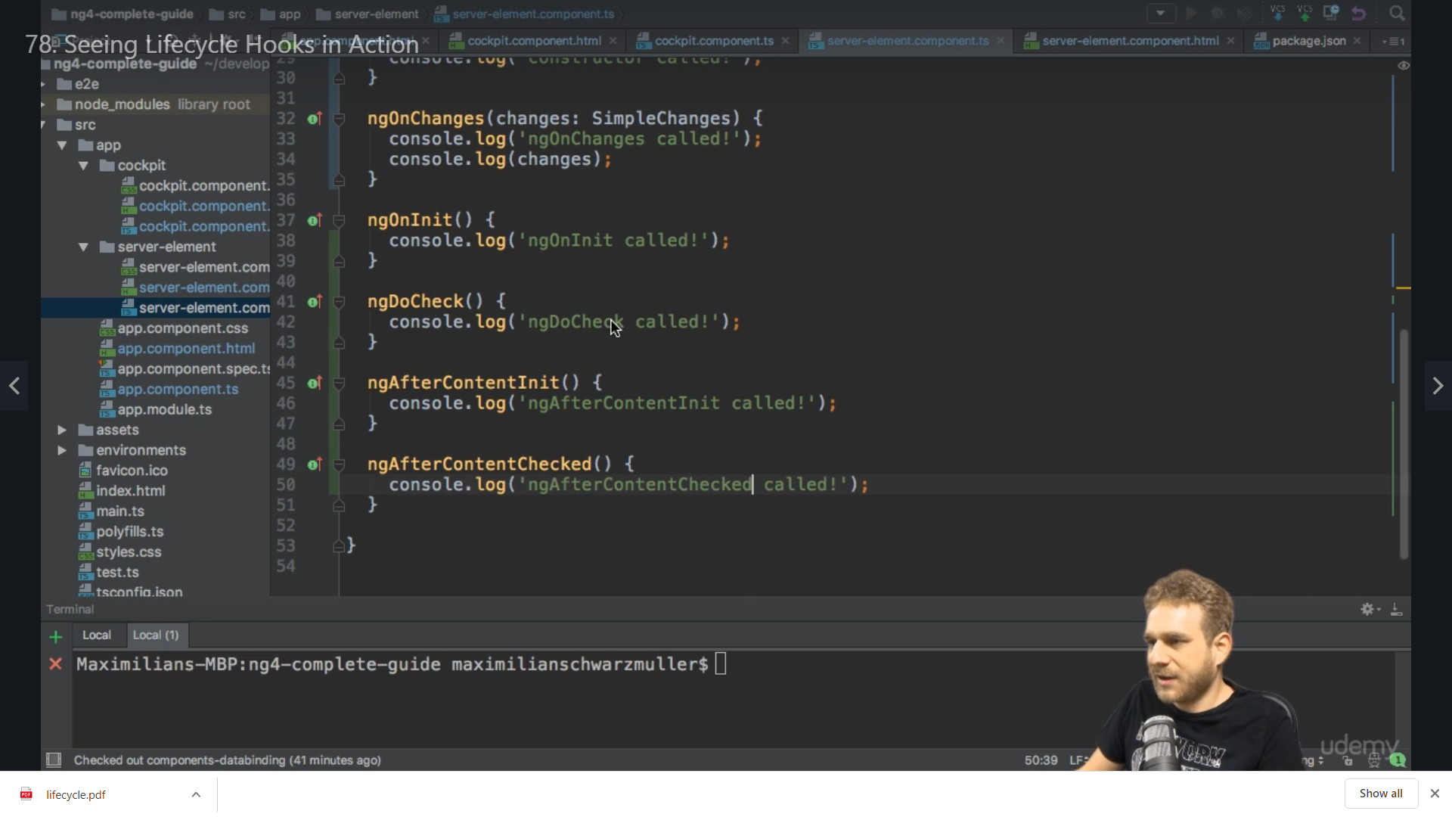

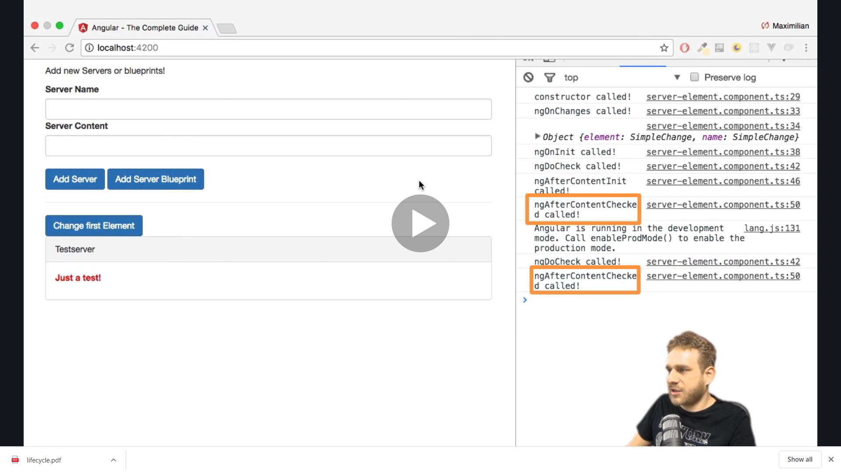

**6,7) ngAfterViewInit ,ngAfterViewChecked**

**After implementing**

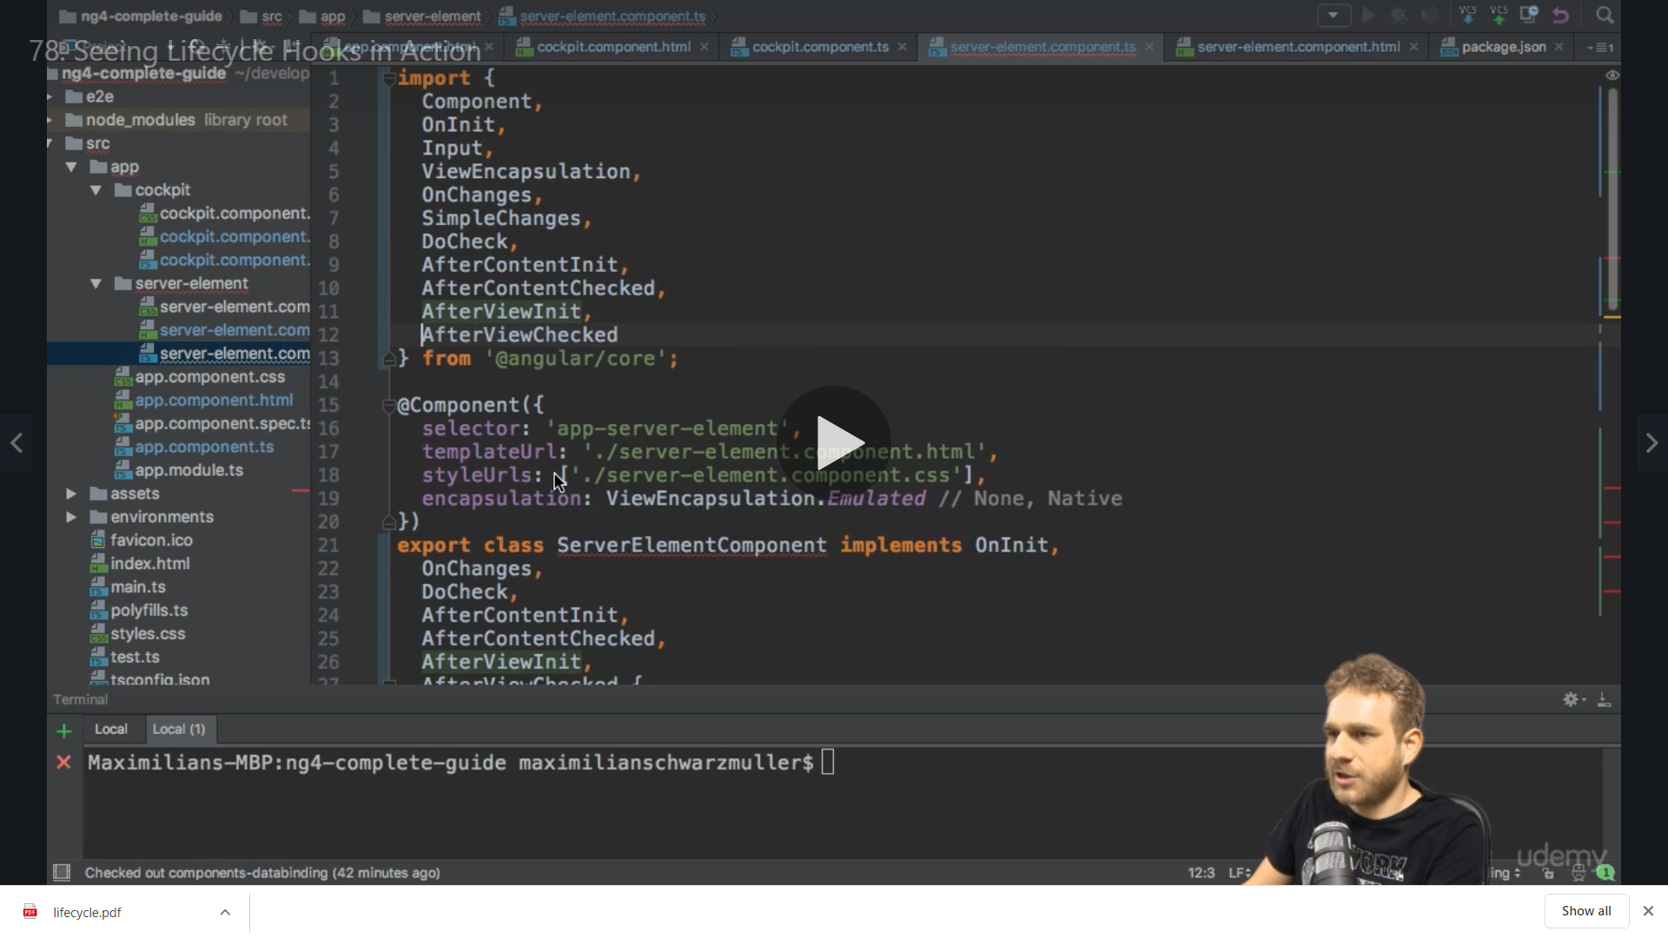

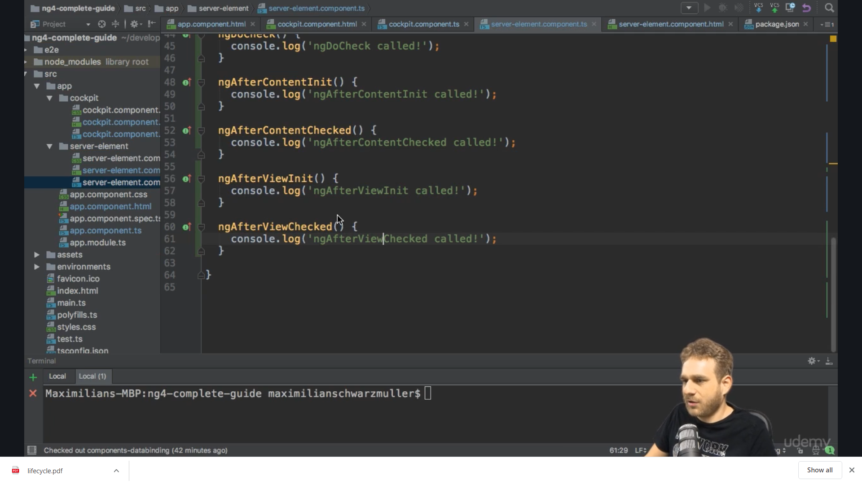

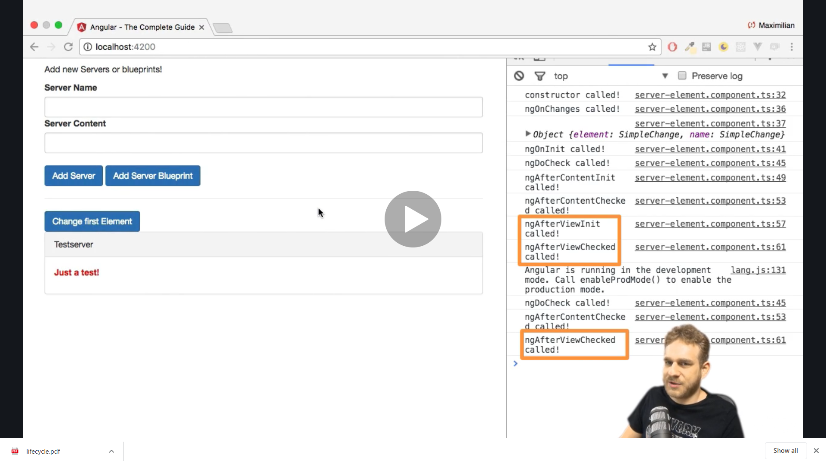

**8) ngOnDestroy**

**We implement the method**

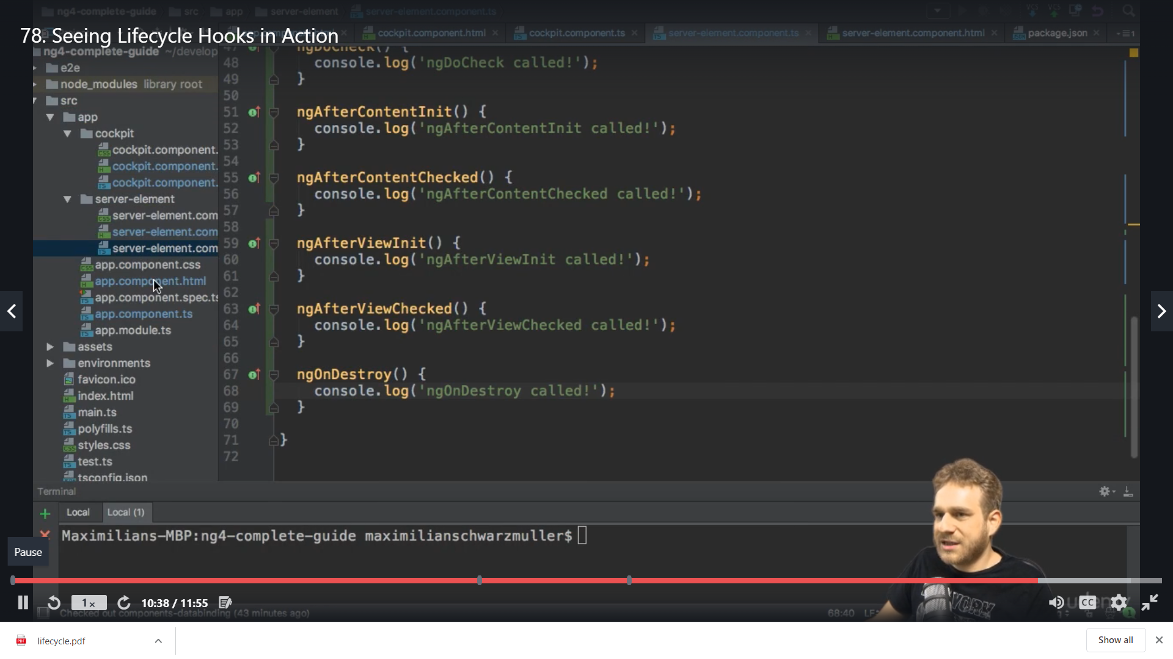

**To see this getting destroyed we will add a new button Destroy first and add method**

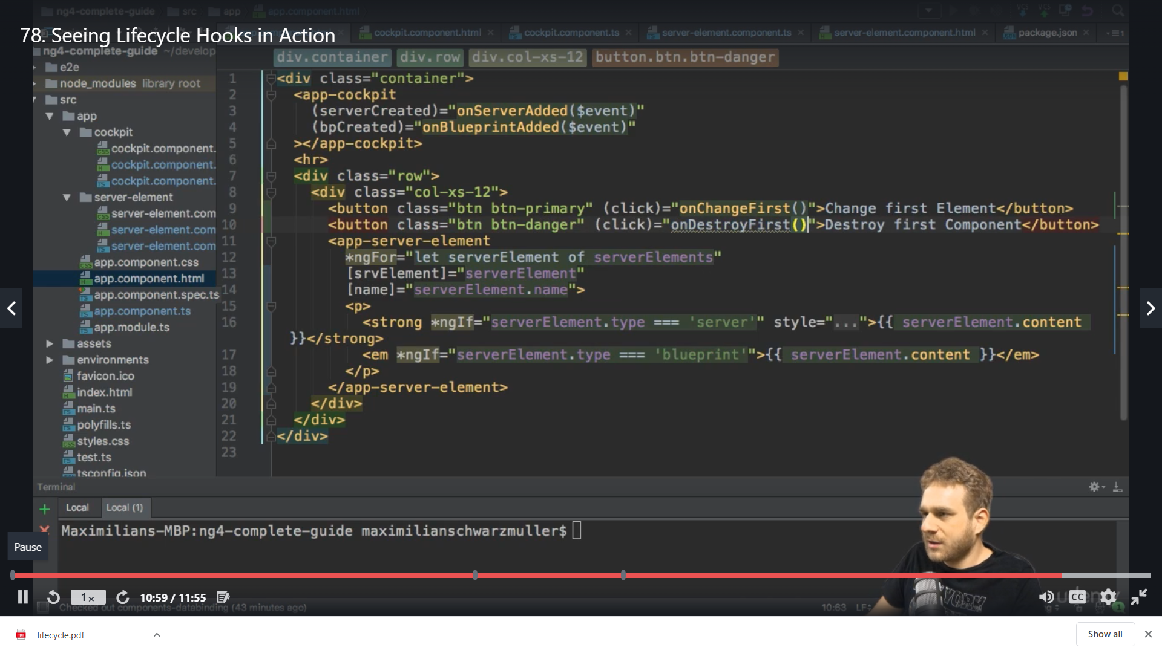

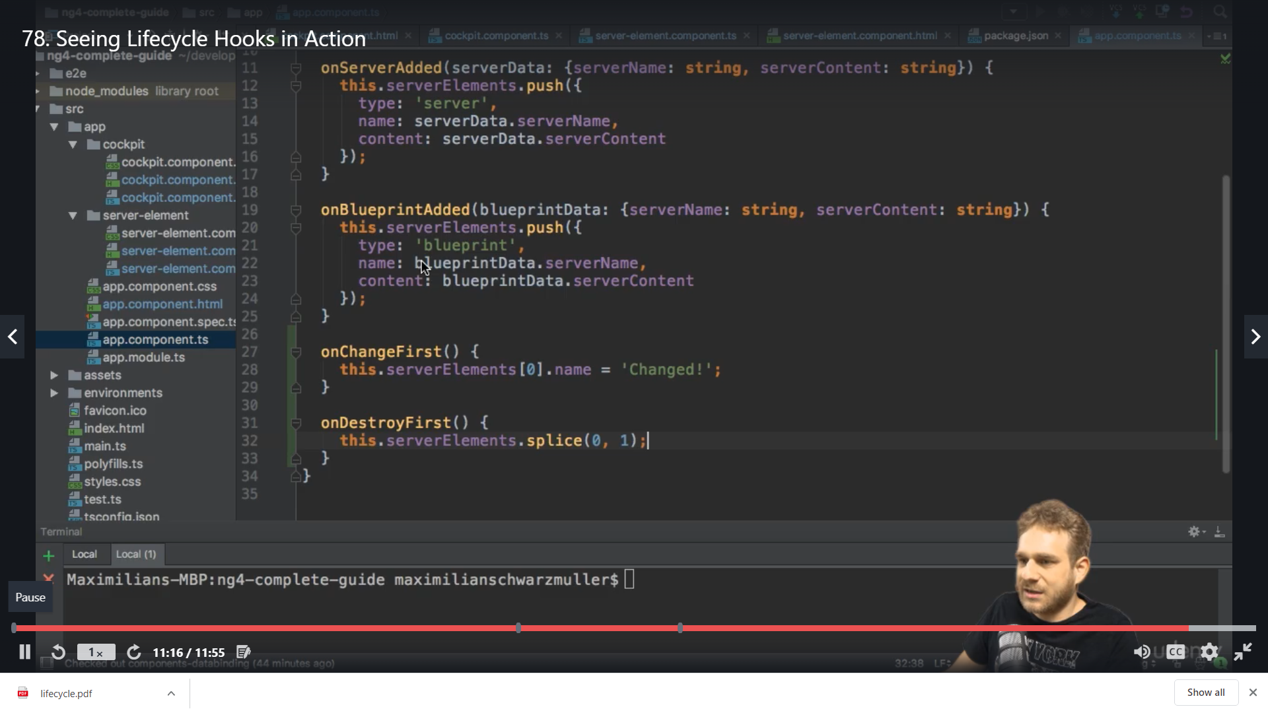

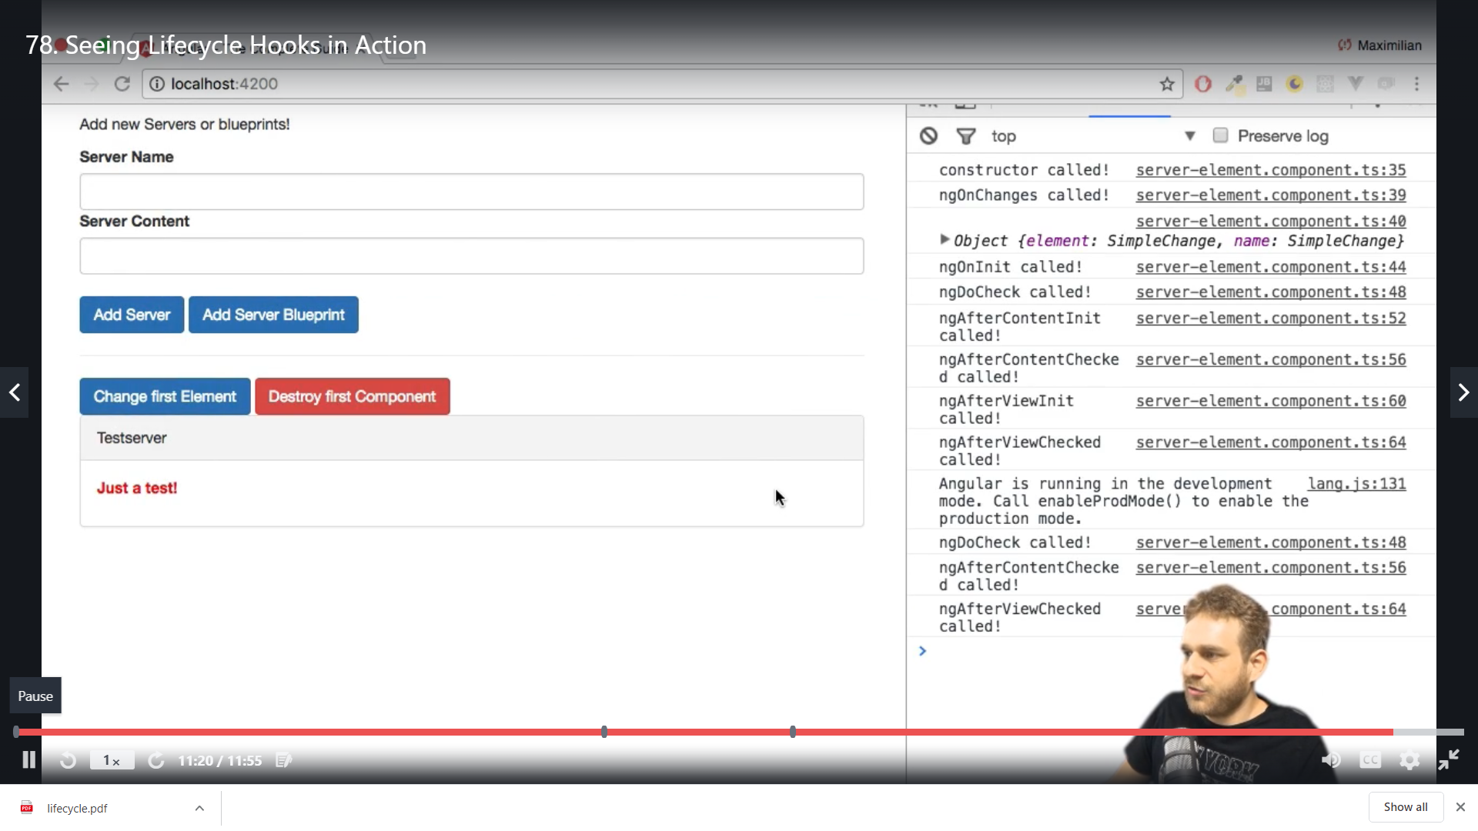

**By clicking destroy the below component gets destroyed**

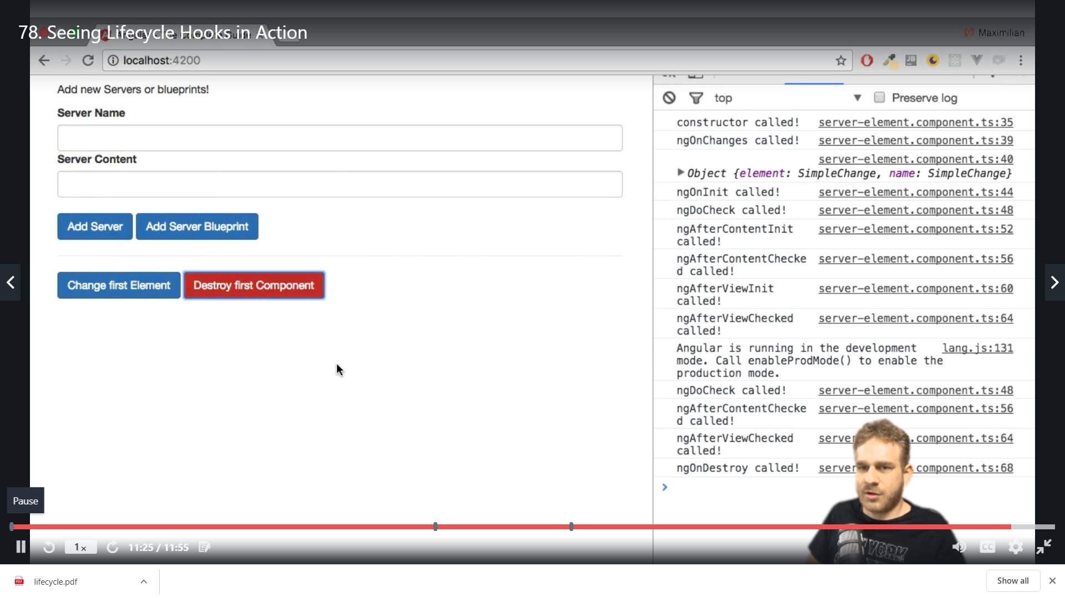

**Lifecycle hook and Template access**

We want to get access to the heading below in my-comp2.component

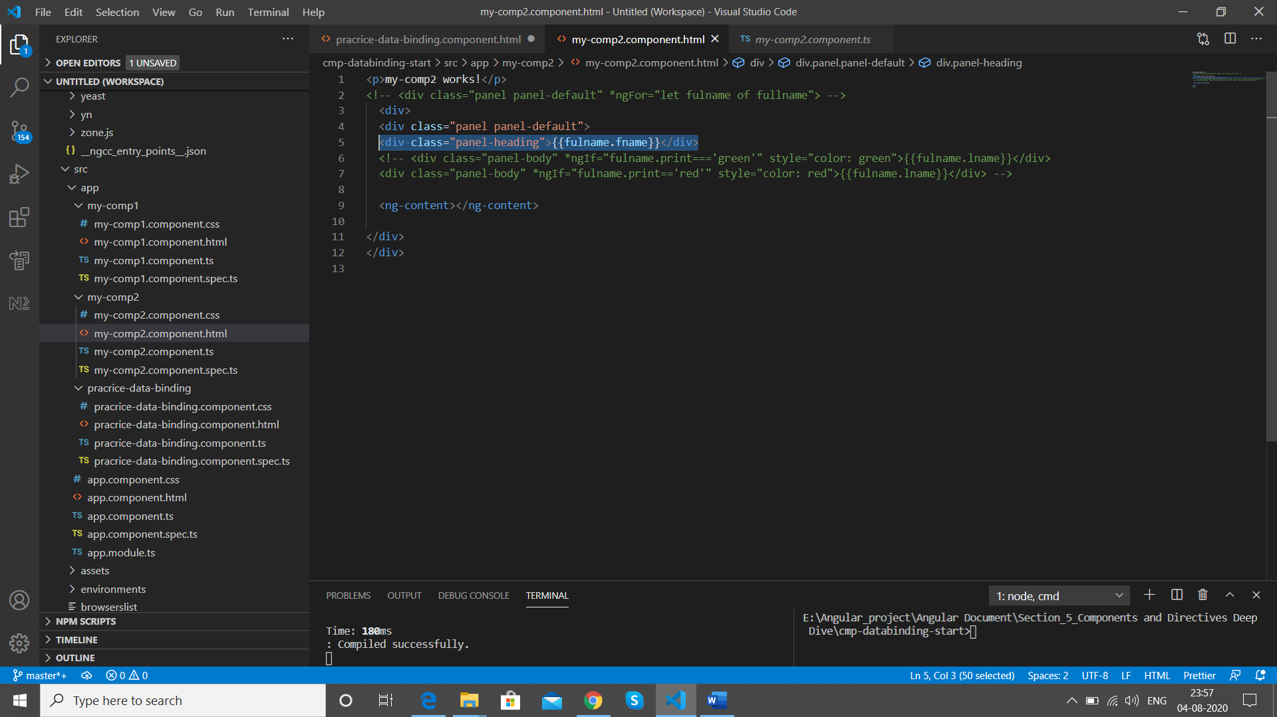

We place a local reference name #heading on it

 <div class="panel-heading" #heading>{{fulname.fname}}</div>

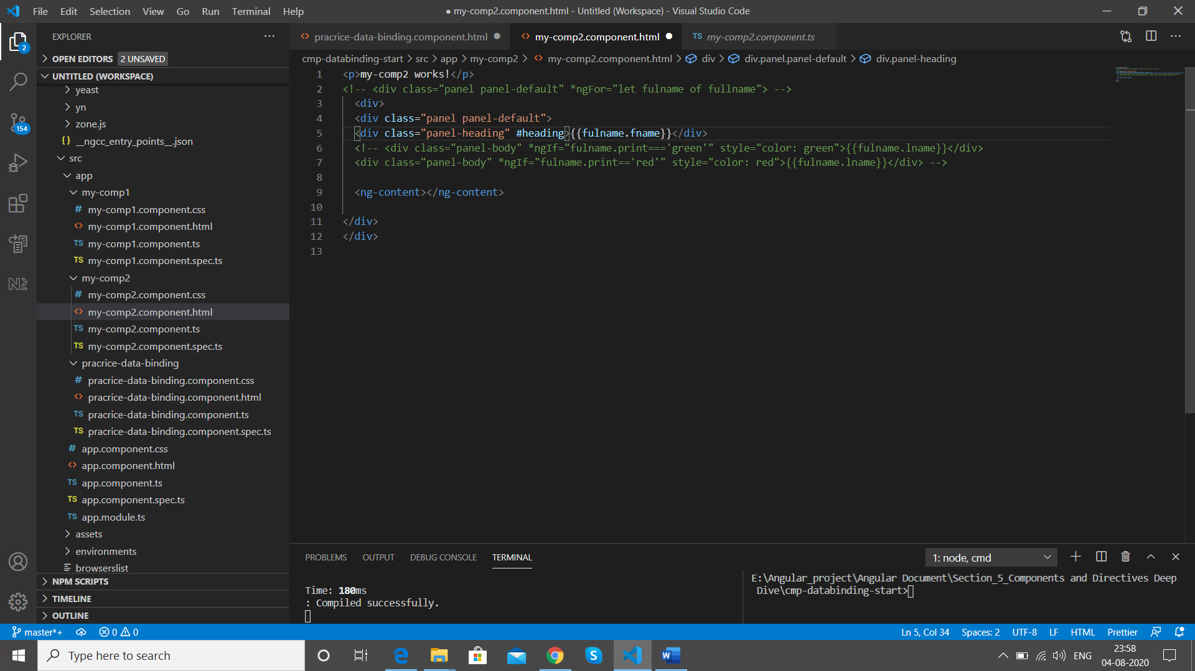

Im my-comp2 component .ts file we use @ViewChild

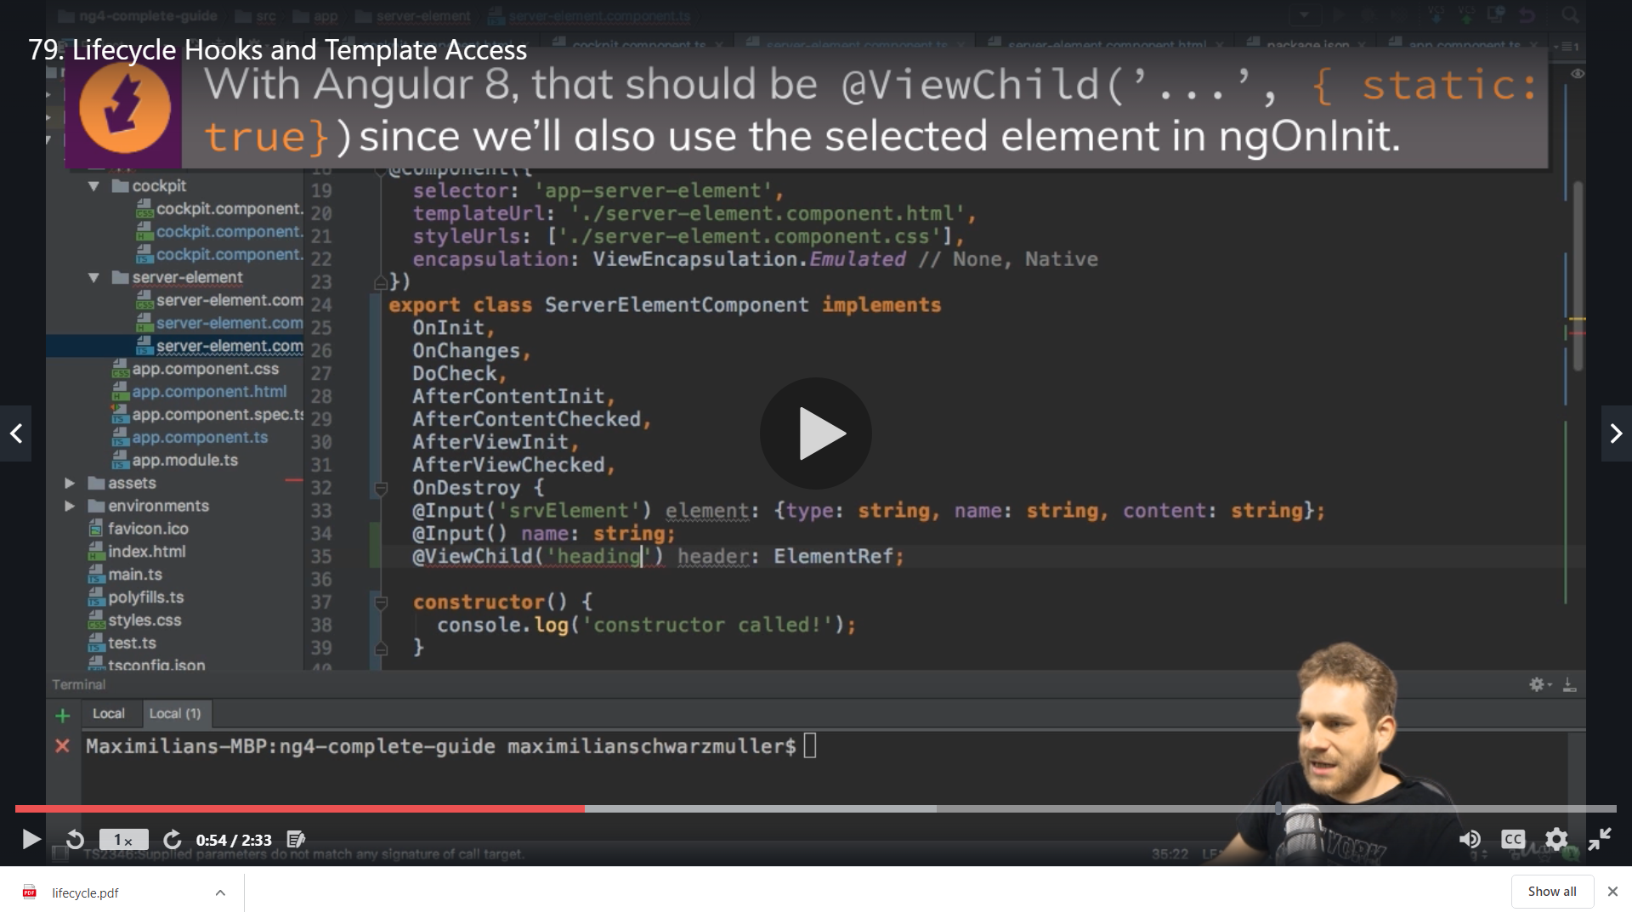

'heading'

Is our local reference name on html

#heading

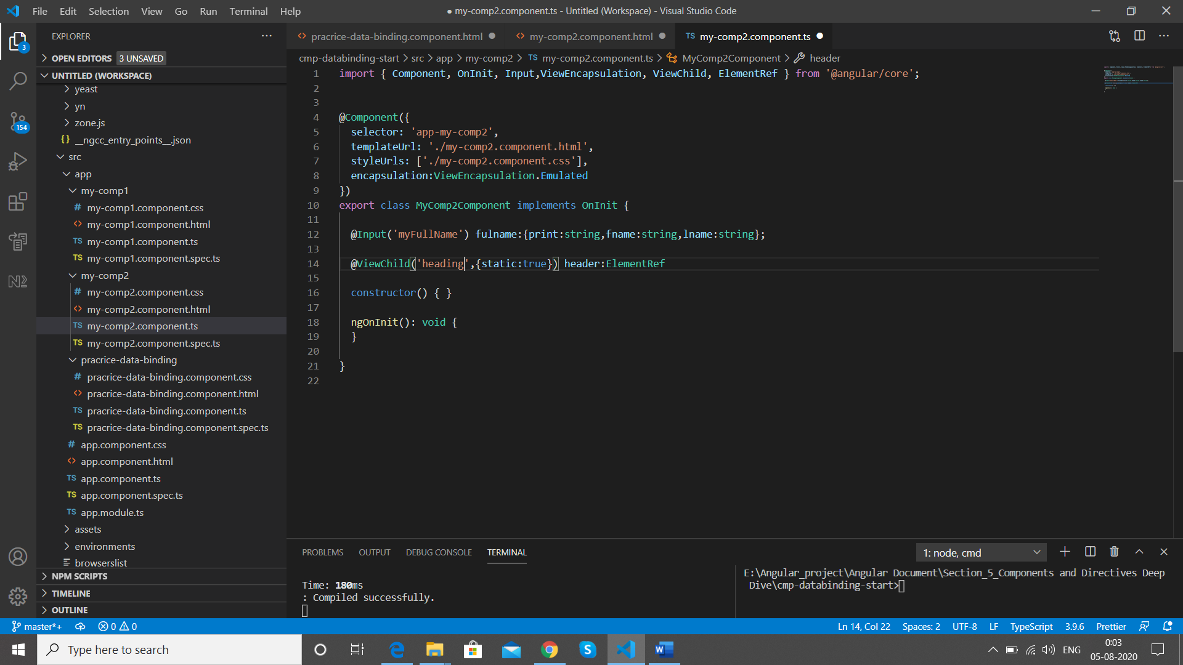

We use header in ngOnInit

  ngOnInit(): void {

    console.log(this.header.nativeElement.textContent);

  }

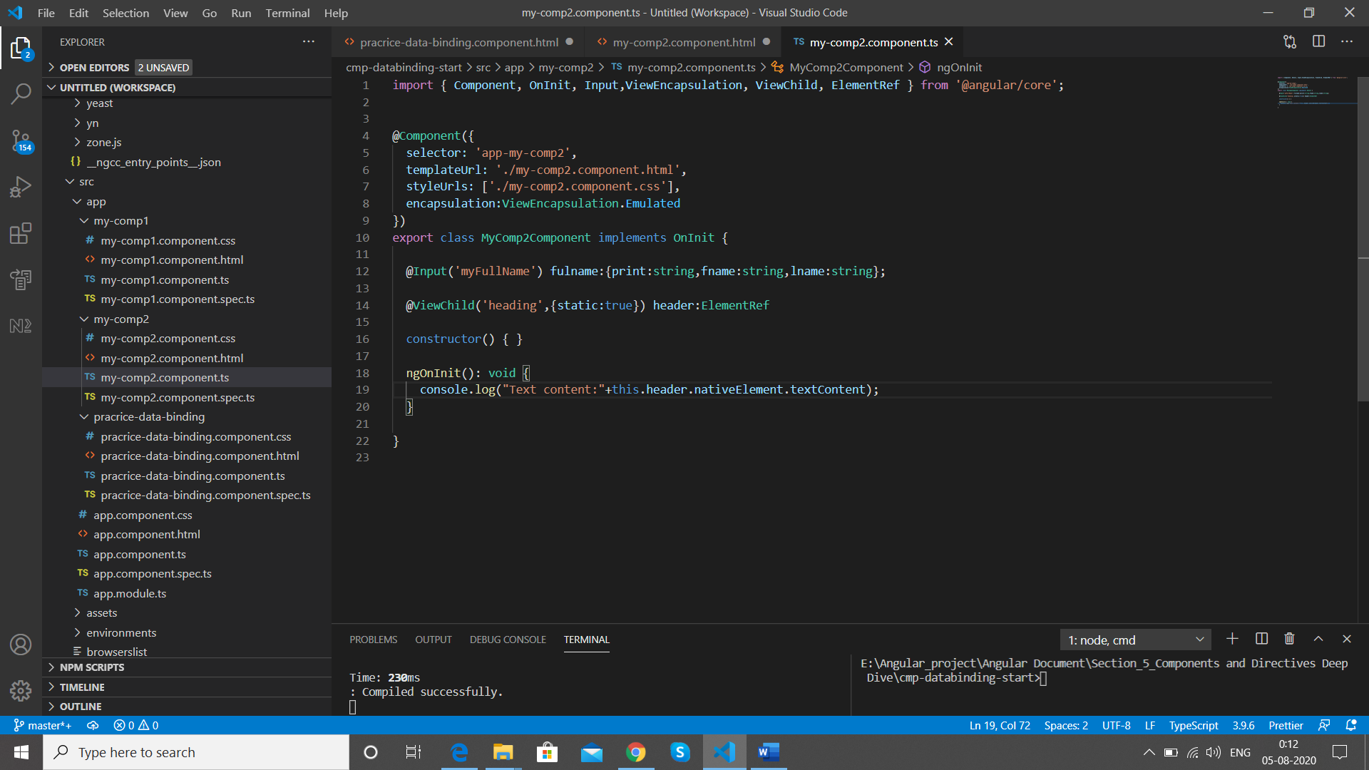

We are getting error as we have not made changes follow the same ss after save

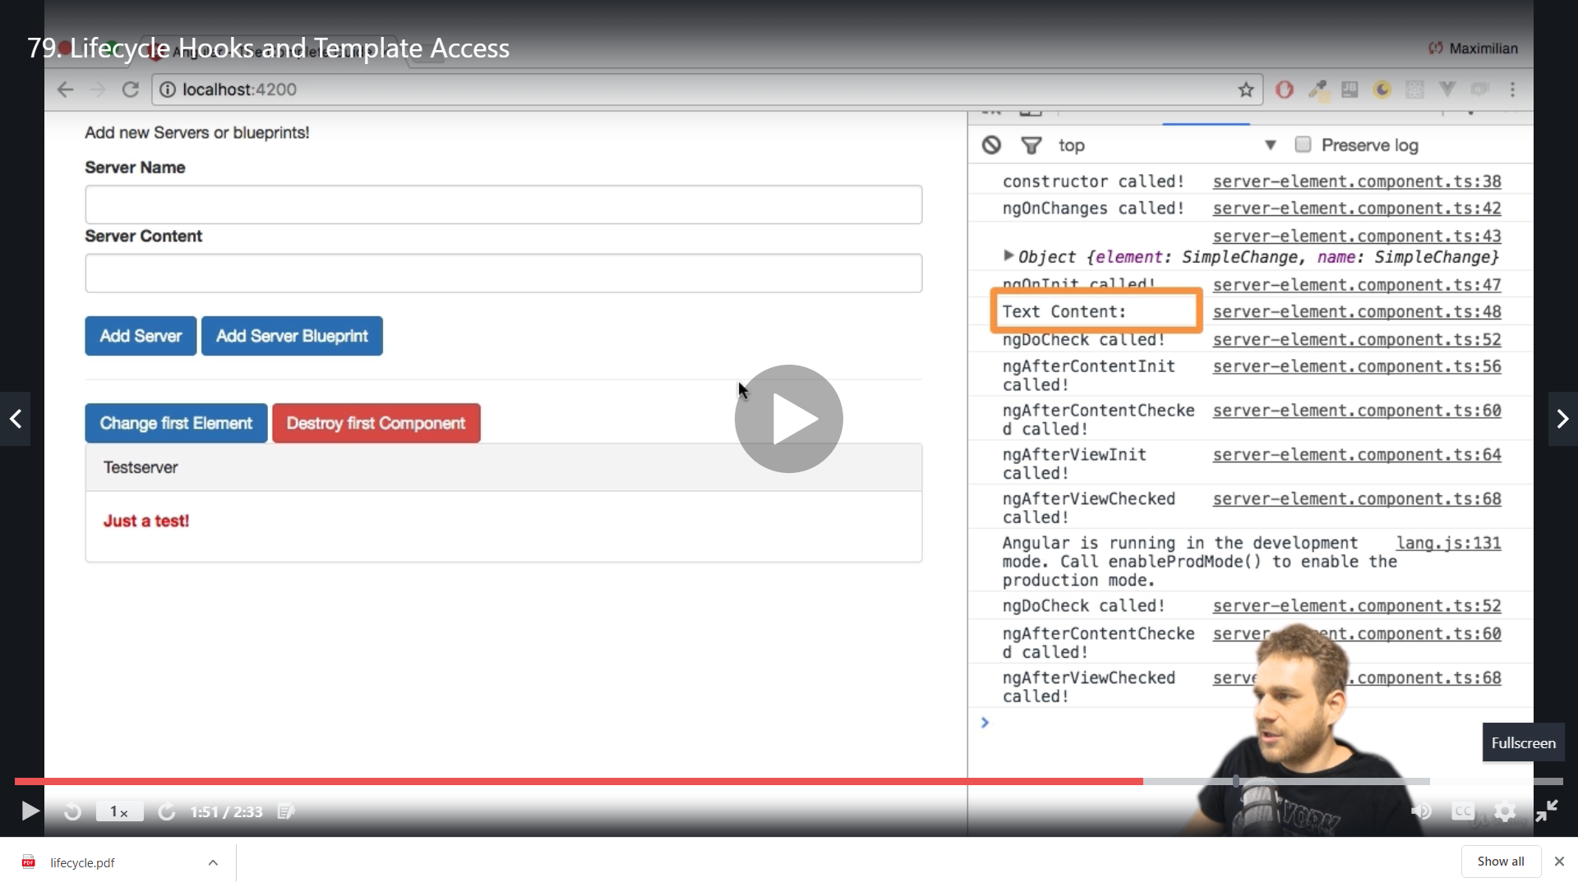

We get empty

If we copy and paste it in ngAfterViewInitI()

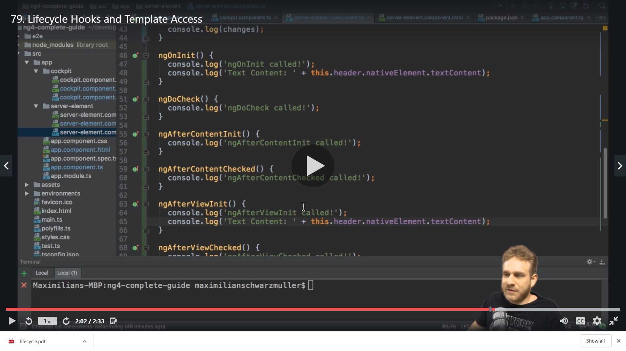

Now we get the value

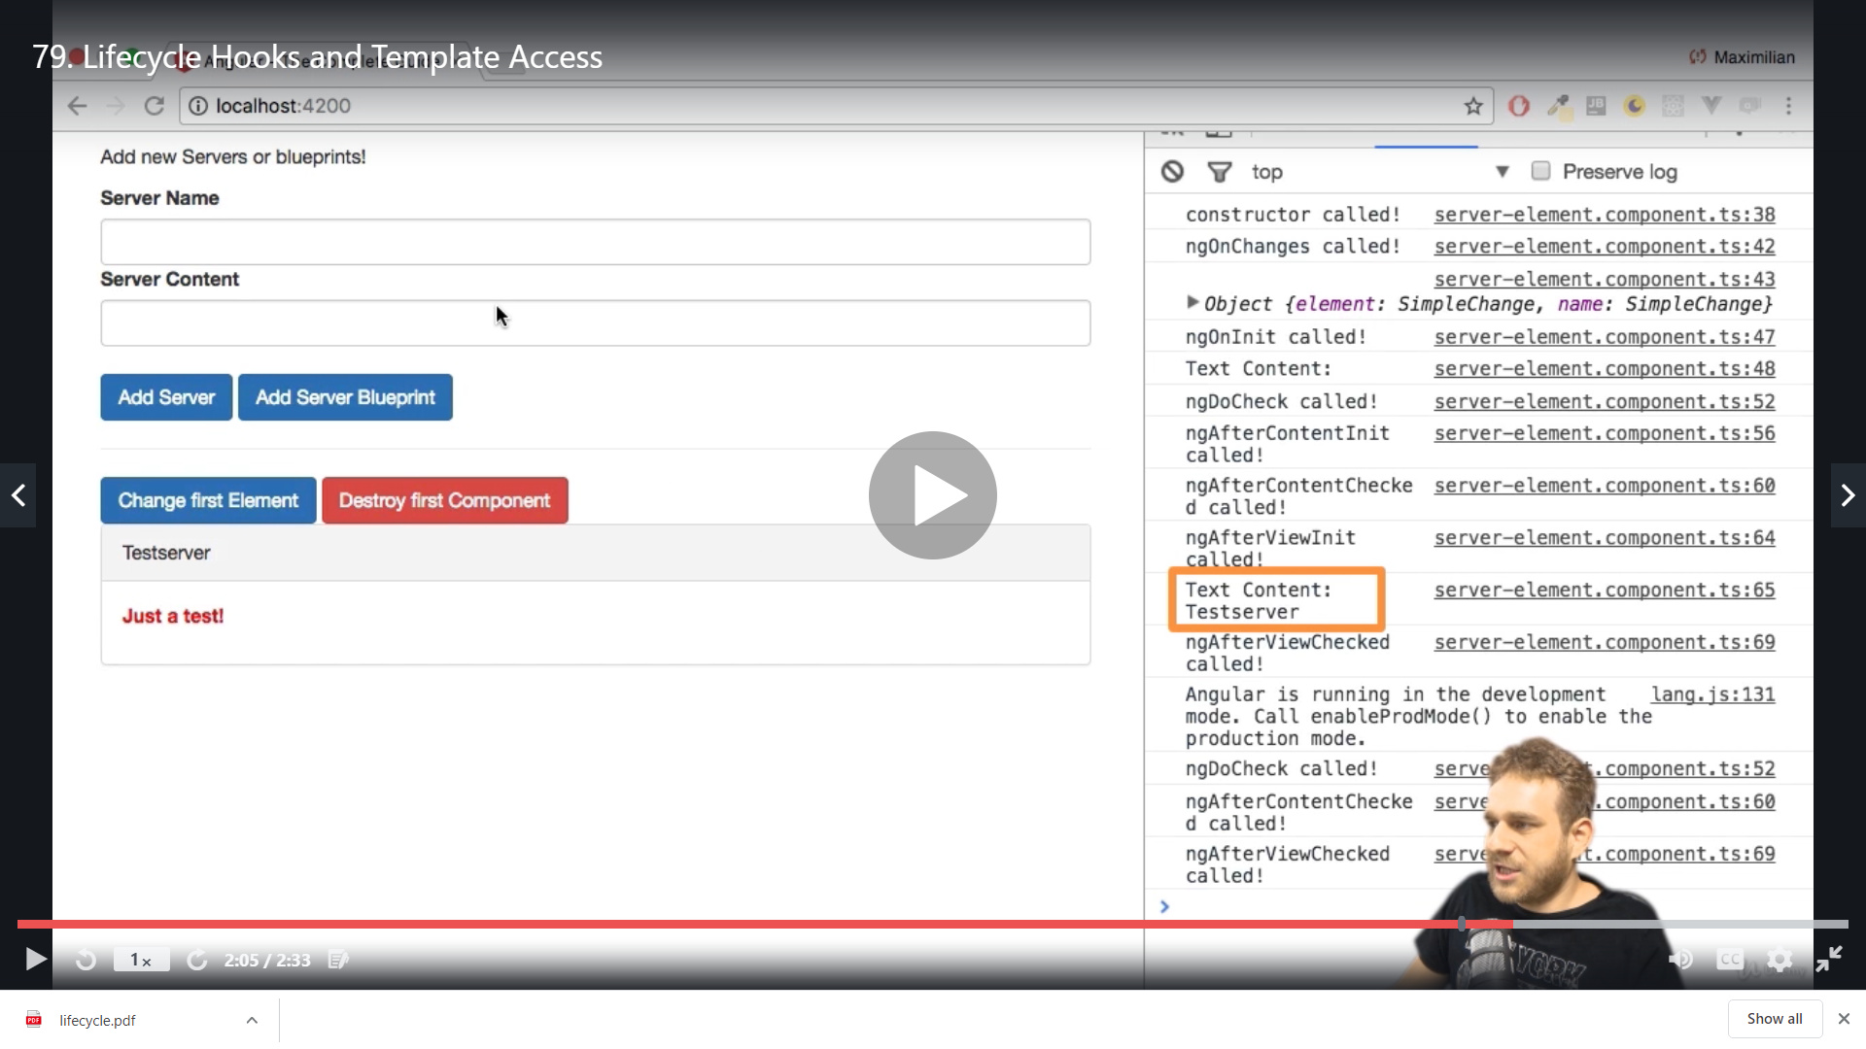

This is the difference between the hooks running ,

To check a value of element in DOM it has to be first rendered

**@ContentChild() in Angular 8+**

In **Angular 8+**, the @ContentChild() syntax which you'll see in the next lecture needs to be changed slightly:

Instead of:

1. @ContentChild('contentParagraph') paragraph: ElementRef;

use

1. @ContentChild('contentParagraph', {static: true}) paragraph: ElementRef;

The same change (add { static: true } as a second argument) needs to be applied to ALL usages of @ContentChild() if you use the selected element inside of ngOnInit (as we do it in the lectures).

If you DON'T use the selected element in ngOnInit, set static: false instead.

We want to access our below highlited code in Parent component(practice data binding component) in child component

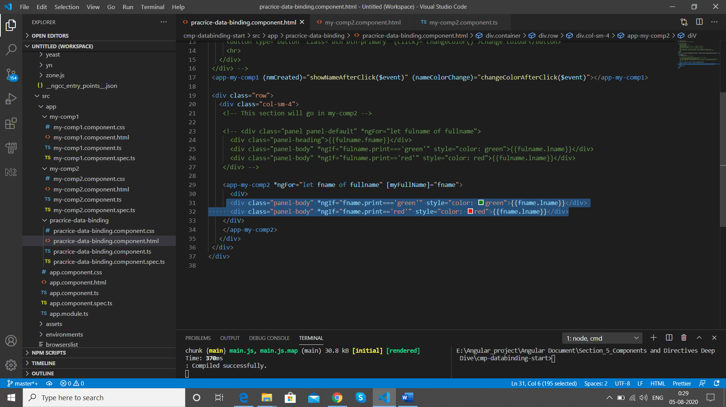

We create a local reference to the div

#myDivData

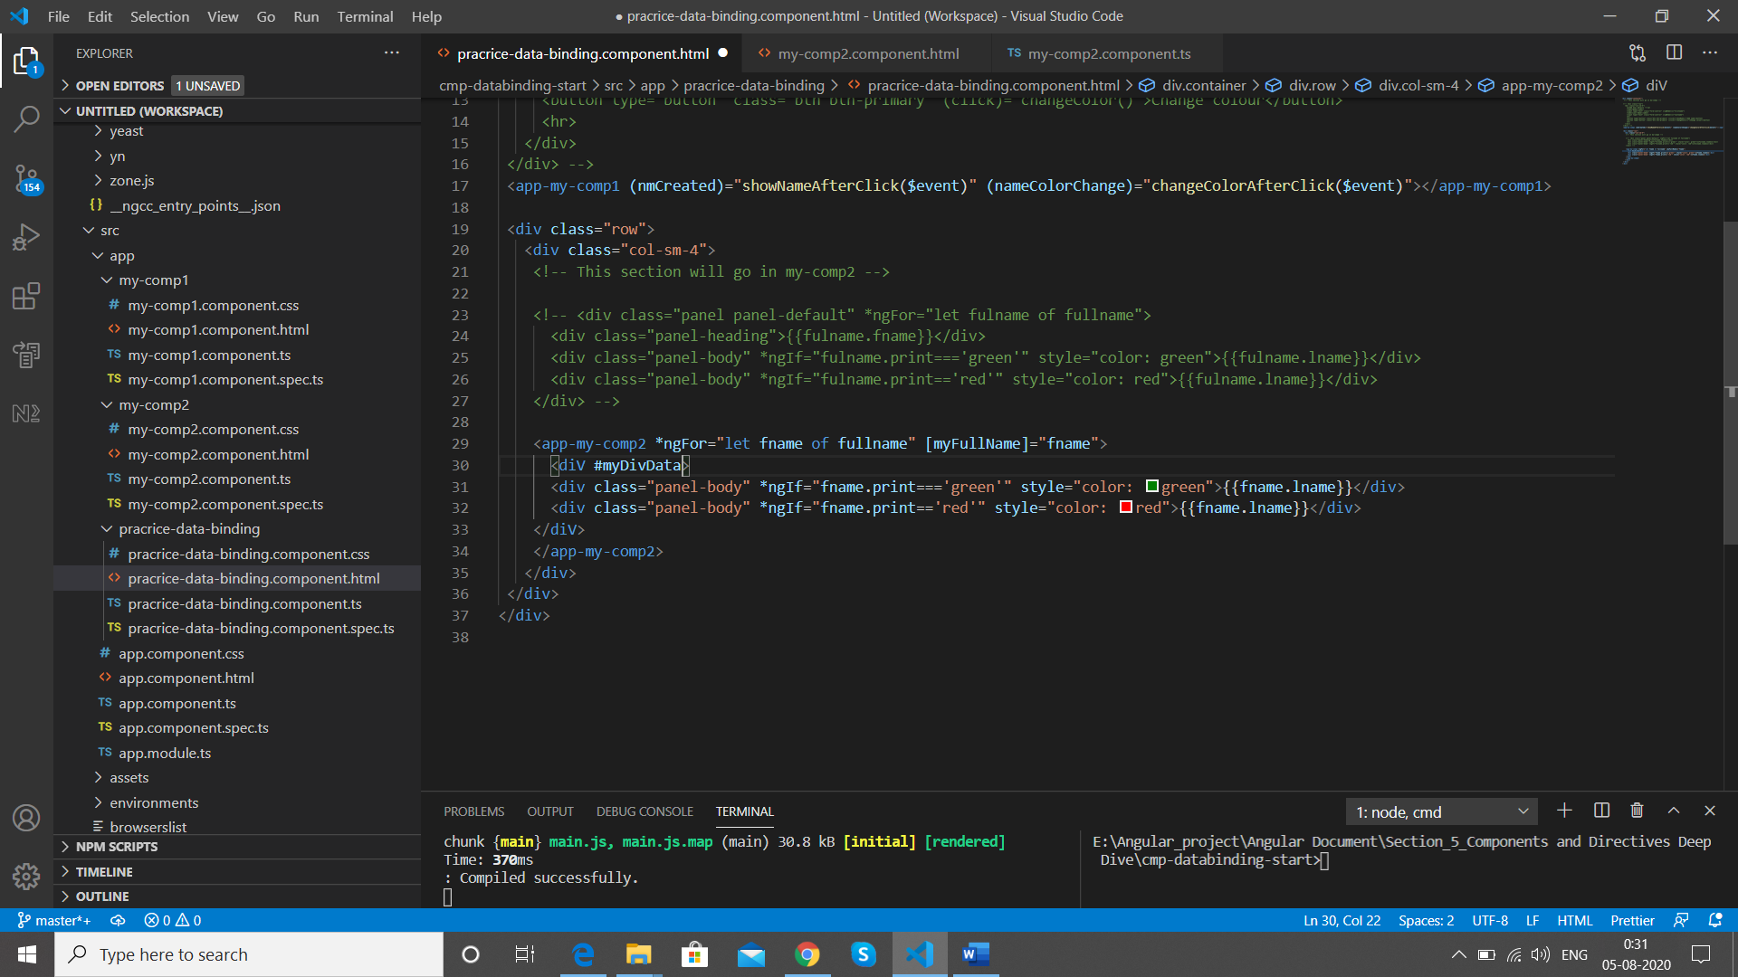

Here we want to use the content of our view in my-comp2 component , but now @ViewChild will not work because it is not part of the view it’s the part of content now as we have implemented it in <ng-content> so we have separate hooks for content

ngAfterContentInit() and ngAfterViewInit()

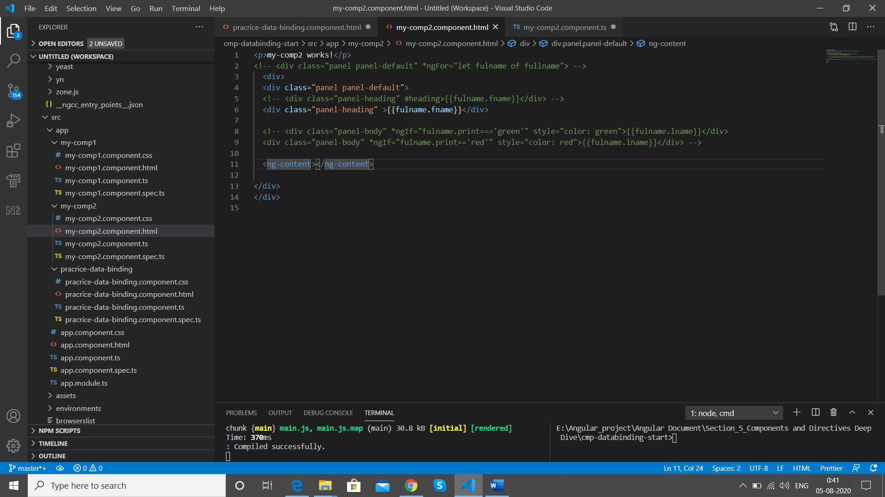

So we add @ContentChild in my-comp2 component

'myDivData'

is

#myDivData

We add ContentChild from Core

import { Component, OnInit, Input,ViewEncapsulation,ElementRef, ContentChild } from '@angular/core';

  @ContentChild('myDivData',{static:true}) myDivData2:ElementRef

myDivData2

is our property

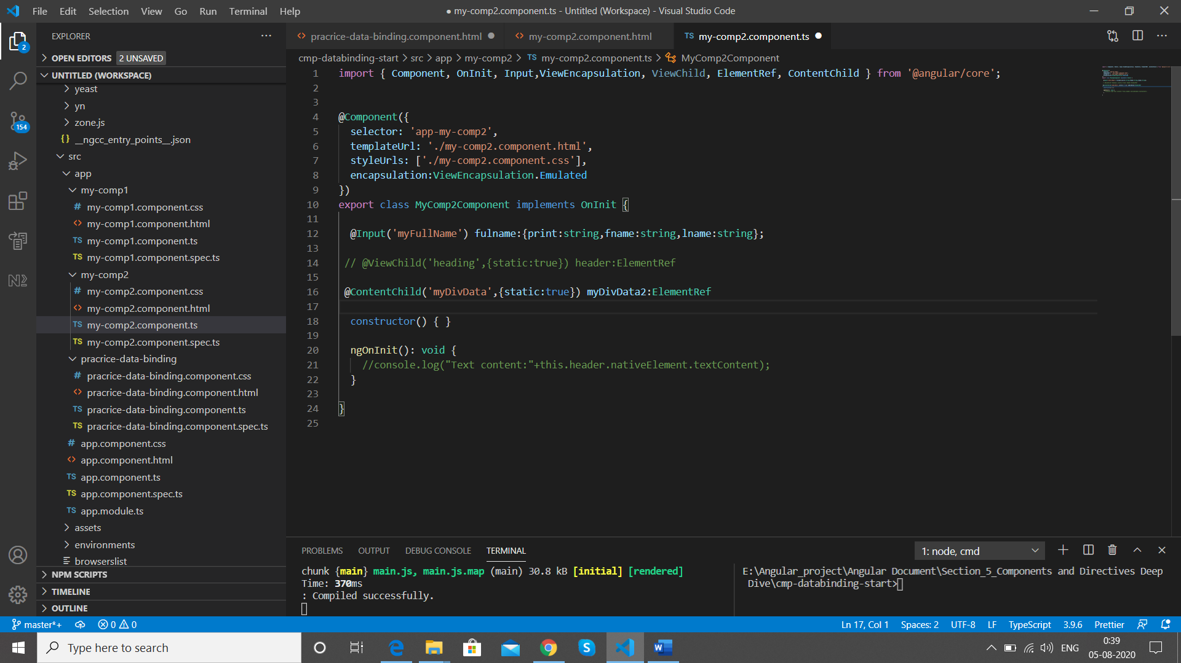

We cannot get the value of it before we reach ngAfterContentInit hook

The @ContentChild is used to get access to content which is stored in another component but then passed on via <ng-content>

Now we log to console

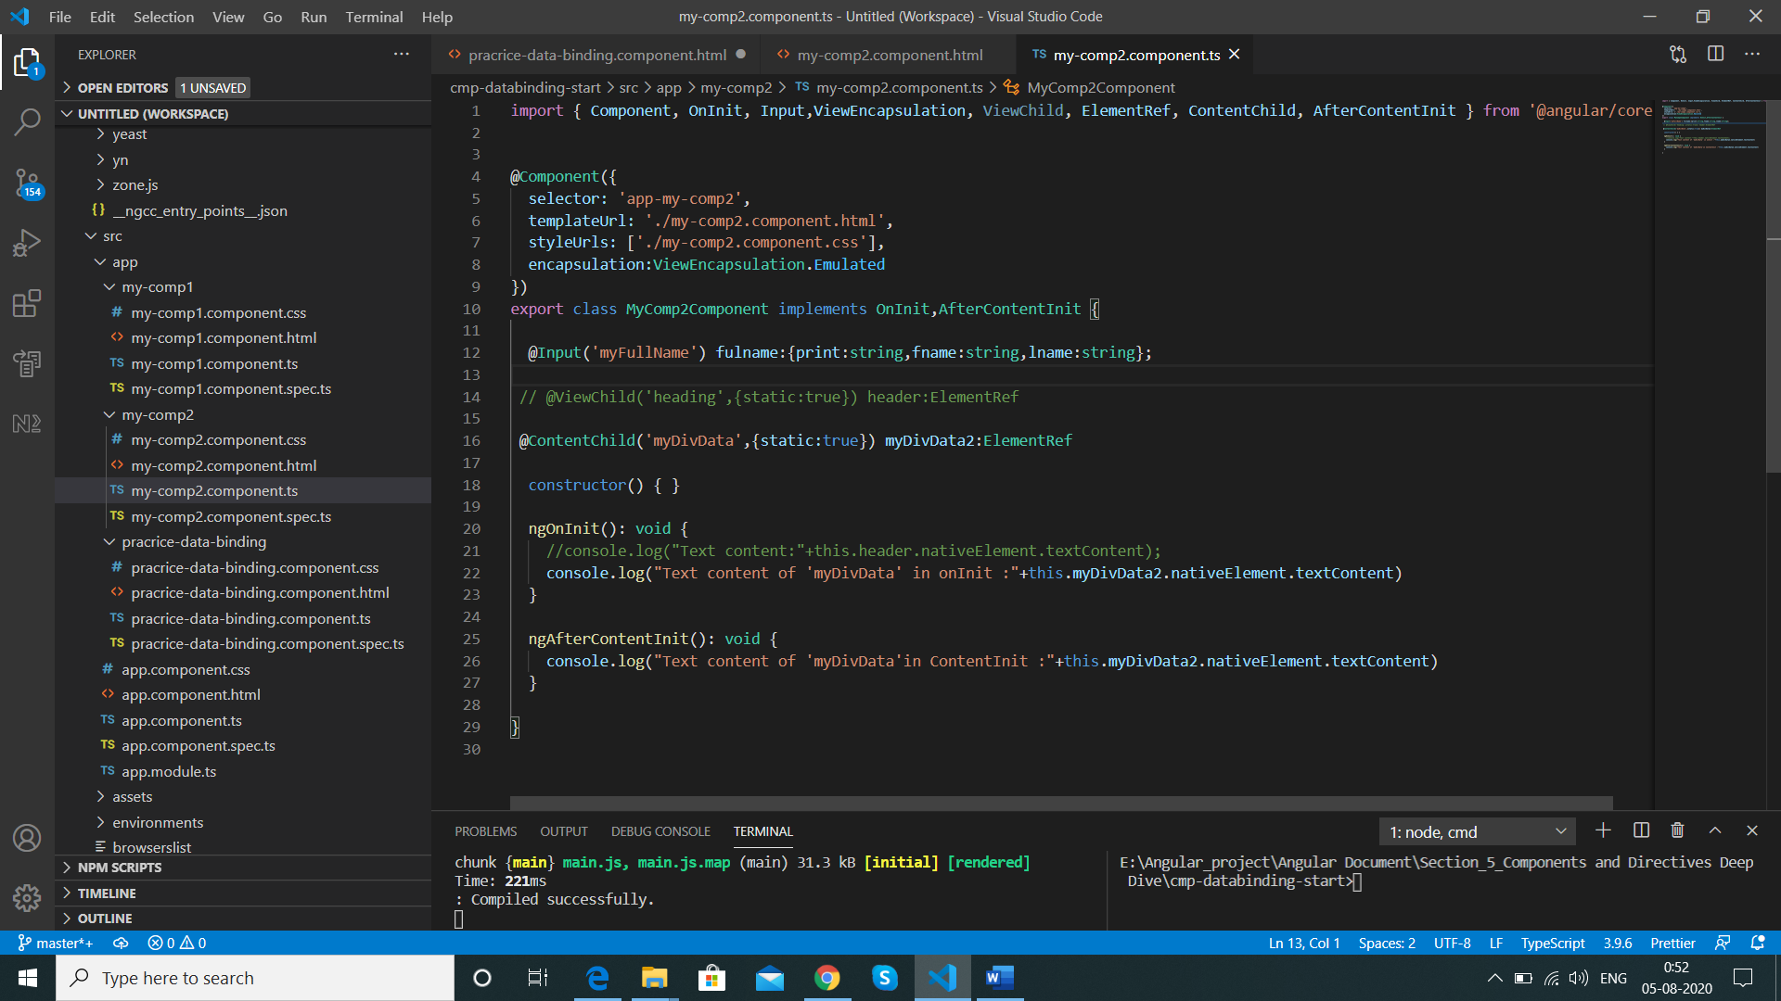

We are get in console below console log which shown that the ContentInit is giving the value and OnInit is blank

Text content of 'myDivData' in onInit :

my-comp2.component.ts:26 Text content of 'myDivData'in ContentInit :Kazi

